Name of the Programme : Debate on ‘Social or Environmental Justice?’
Date & Venue : 17/07/2019, Seminar Hall
Brief Description of the programme:
The programme was organized in Association with the Department of English.
Number of Participants:
13

Name of the Programme : Debate on ‘Scrapping of Article 370’
Date & Venue : 13/08/2019, Seminar Hall
Brief Description of the programme:
The programme was organized in Association with the Department of Economics. The first prize was bagged by the Department of Physics and the second by the Department of Economics.
Number of Participants:
11

Name of the Programme : Group Discussion on “Malayalam Newspapers Today – A Youth Perspective”
Date & Venue : June 8th 2018, Centre for Researh and Consultancy, Kaloor.
Brief Description of the programme:
Participants:
a. Amolk Ravi
b. Abhishek ER
c. Mayika M
d. Devu Ramesh
e. Anna Mariya Oommen Mathew
f. Riya mary
g. Jackson Joy
h. Diyana B Shahjahan
g. Isabel Harald

Number of Participants: 9

Name of the Programme: Debate competition on the topic “Is Mercy Killing the Need of the Times”
Date & Venue: 26.07. 2018, Seminar Hall
Brief Description of the programme:
- The following were the Best Debator Prize winners

- I- Santhi MS- III BA English
- II- Maria Argent Deepthi- III BA Economics
- III- Gonzalo Akhil- III BSc Maths
Number of Participants: 9

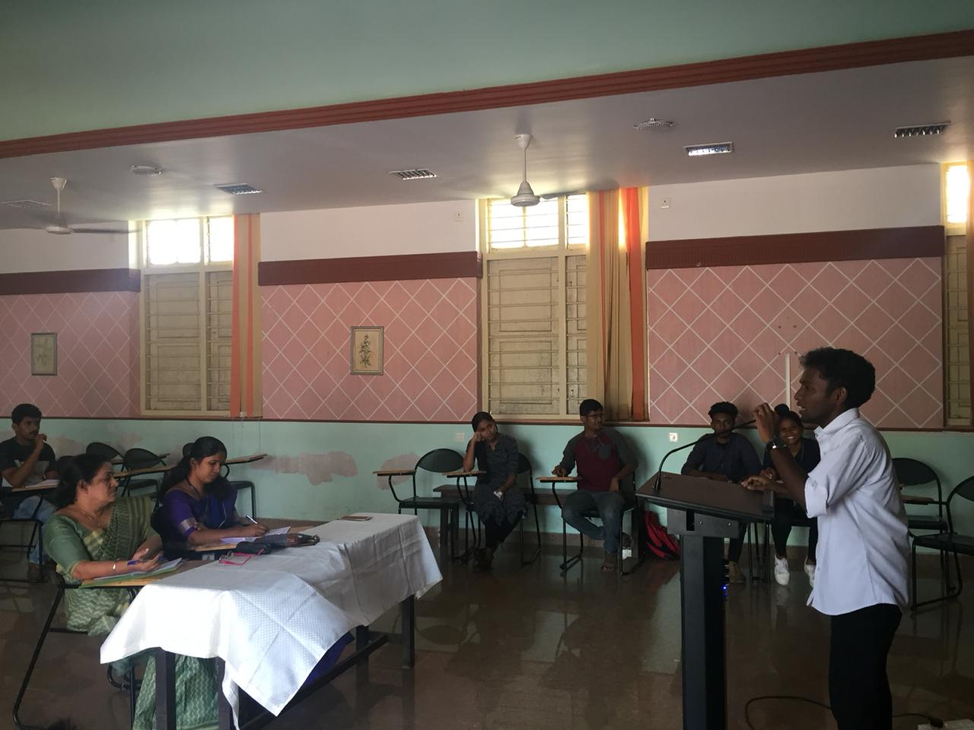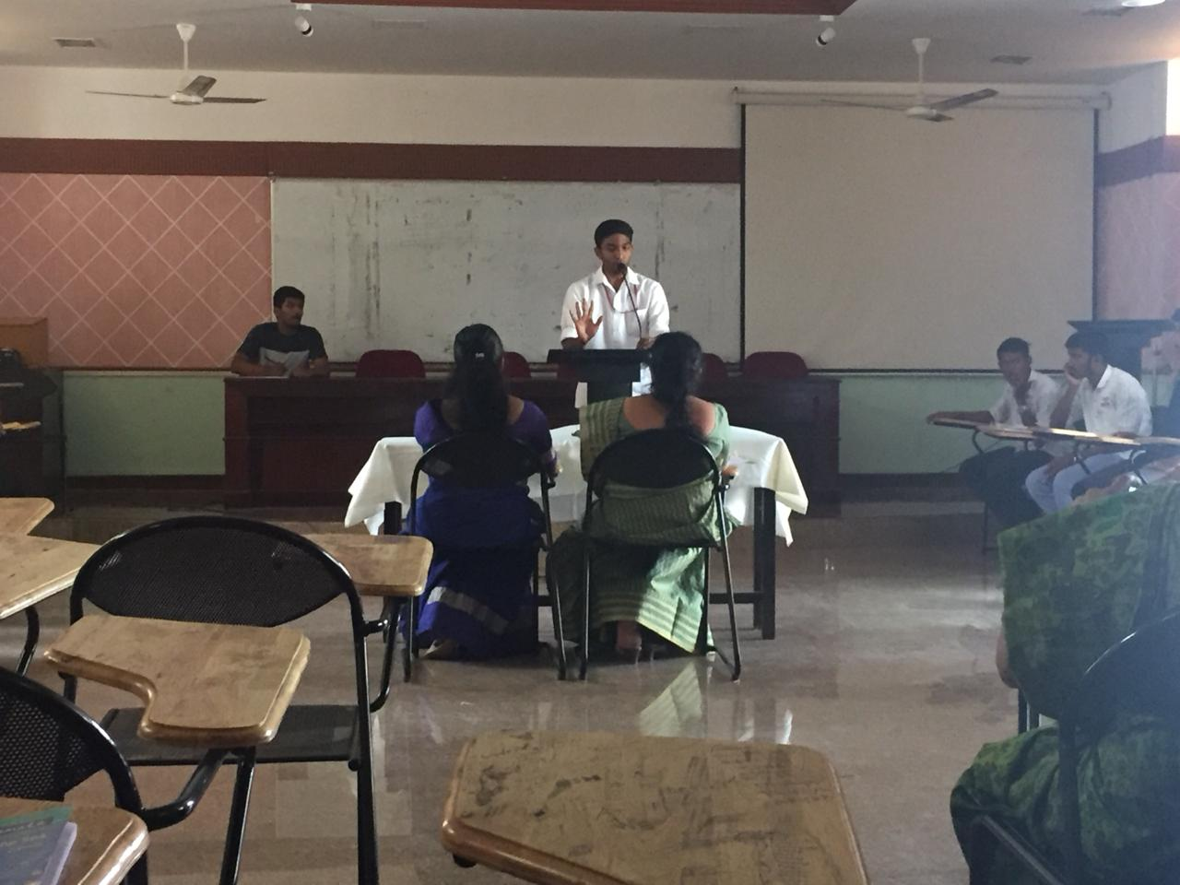

Name of the Programme: Inter Collegiate Debate
Date & Venue: 6th and 7th November, 2017, Maharaja’s College
Brief Description of the programme:
Participants:
a. Ms. Prabitha Lakshmi T S, II M A Economics
b.Mr. Jackson Joy, II M A Economics
Number of Participants: 2

Name of the Programme: Inter Collegiate Debate
Date & Venue: 25/10/2017, Union Christian College, Aluva,
Brief Description of the programme:
a. Regeena Teena D Costa, II M A Economics
b. Archith T Niranj, I B A English Model II
c. Alan Jacob John, I B Sc Chemistry
d. Sreelakshmi R Nair, III B A English Model II
Number of Participants: 4

