Name of the Programme: Communicative English Class
Date: 15/11/2018
Venue: Seminar Hall
Brief Description of the programme:
It was a ten day programme started with the aim of making students more fluent in the language. The workshop helped students to know the importance of communication and training to handle situations. There were practical sessions to help students themselves practice the skills.
Number of Participants: 38
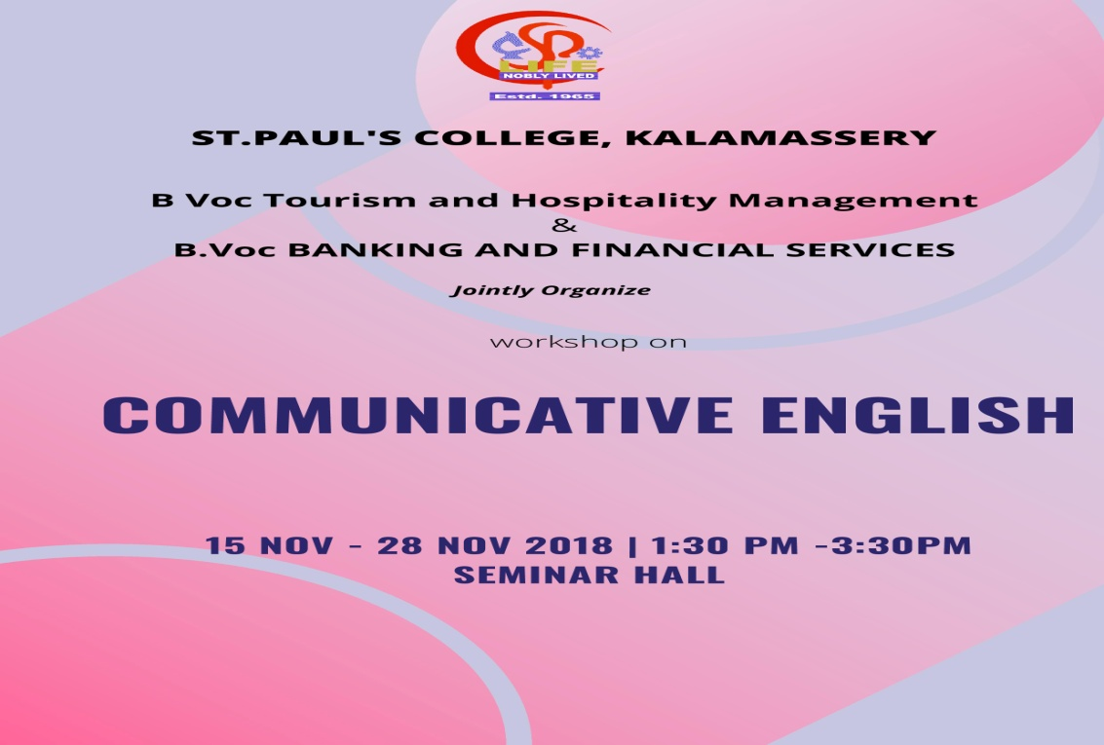

Name of the Programme: Wetland and Responsible Tourism
Date: 01/02/2019
Venue: Seminar Hall
Brief description of the programme:
The department conducted a one day seminar on the topic Wetland and Responsible tourism. Prof. Abin KI was the resource person. Through this seminar students were made aware of the uniqueness of wetland tourism and sustainable tourism development. Students were able to know about the importance of responsible tourism and also the importance of wetlands as a natural attraction
Number of Participants: 38
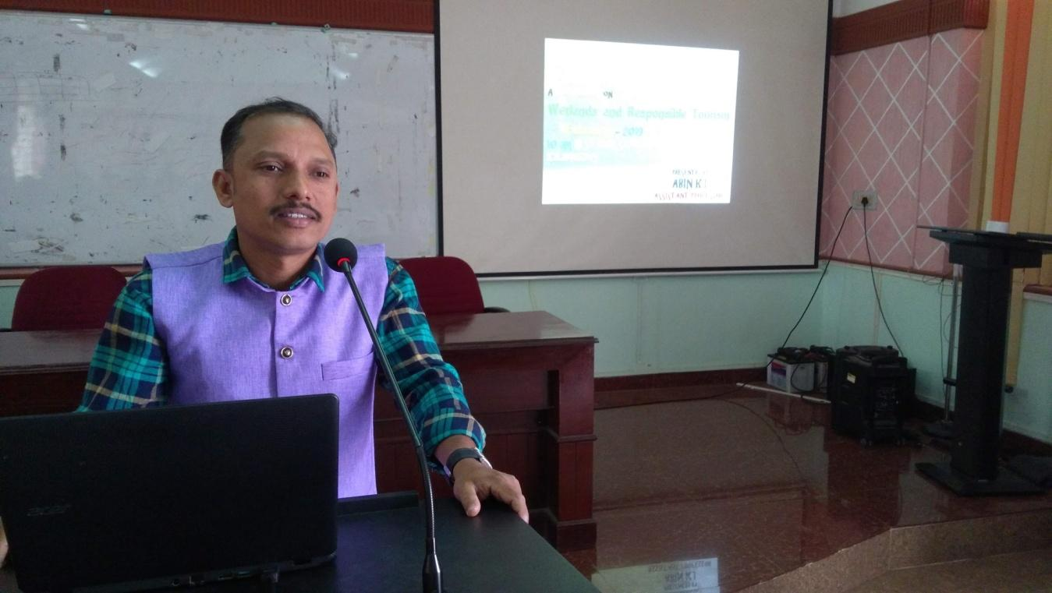
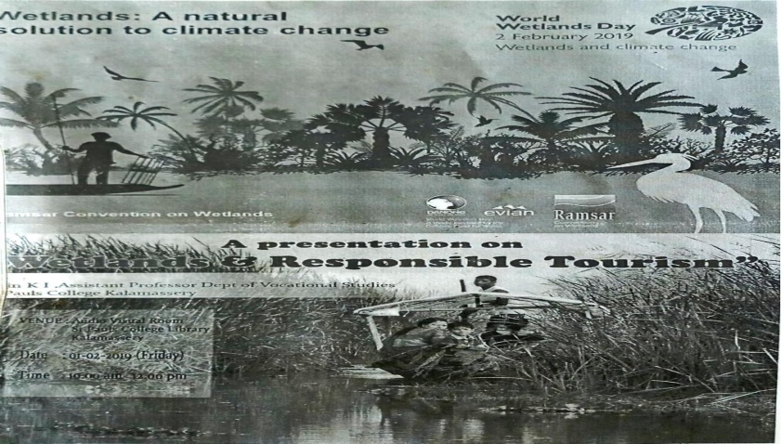
Name of the Programme: Orientation Programme
Date: 20/03/2019
Venue: Seminar Hall
Brief Description of the programme:
The nodal officer of B. Voc. Department, Prof. Stalin P.C. conducted an orientation program for students of B Voc Tourism and Hospitality Management. The program was mainly focusing on confidence building up activities and exam preparation. The students were aware about the importance of professional appearance and importance of skill components in vocational courses.
Number of Participants: 38
