AN ENTREPRENEURIAL AND MOTIVATIONAL TALK
Date: 26/02/2019
No. of Participants: 49
Venue: College Digital Library
Report:
B.Voc Banking and Financial Service conducted AN ENTREPRENEURIAL AND MOTIVATIONAL TALK for the students B.Voc Banking and Financial Services on 26/02/2019.
Objective : The programme was conducted with the aim of inculcating entrepreneurial talents and motivating students to be an entrepreneur.
The session was handled by Mr Aaquib Saneen, Co –Founder of De Graphic Factory.
Students of the batch of B.Voc banking and Financial Services participated for this program
47 students and 2 faculties attended the event.
Documents:
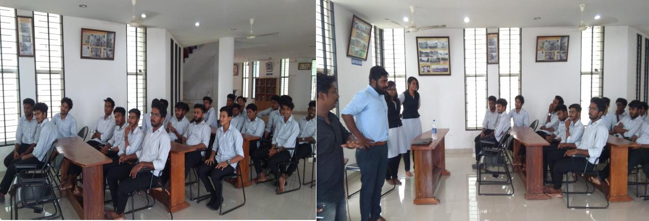

EXAM PREPARATION CLASS
Date: 1st March 2019
No. of Participants: 100
Venue: College Seminar hall
Report:
A seminar was taken by Prof. Stalin PC Nodal Officer, B Voc Programme on 1st March 2019 at College Seminar hall for the students of B Voc Tourism and Hospitality Management & B Voc Banking and Financial Service on the Topic ‘ How to prepare effectively for Board Exams’. Nearly 100 students from both the departments participated in the seminar.
Objective : To prepare students mentally for the B.Voc Board Exams, which is a course of recent origin. Seminar aims to make students face the exams with confidence.
Outcome : students became confident enough to face exams.
Documents :

