STATE LEVEL WORKSHOP ON PFMS
Date: 3rd August 2019
No. of Participants: 60
Venue: College Seminar hall
Report:
The Department of Vocational studies in association with IQAC conducted a State Level Workshop on the uses of Public financial Management System on 3rd August 2019. Around 60 participants from various colleges participated in the workshop. Resource persons from PFMS Cell Trivandrum delivered the classes.
Objective : To create an awareness about Public Financial Management.
Documents :
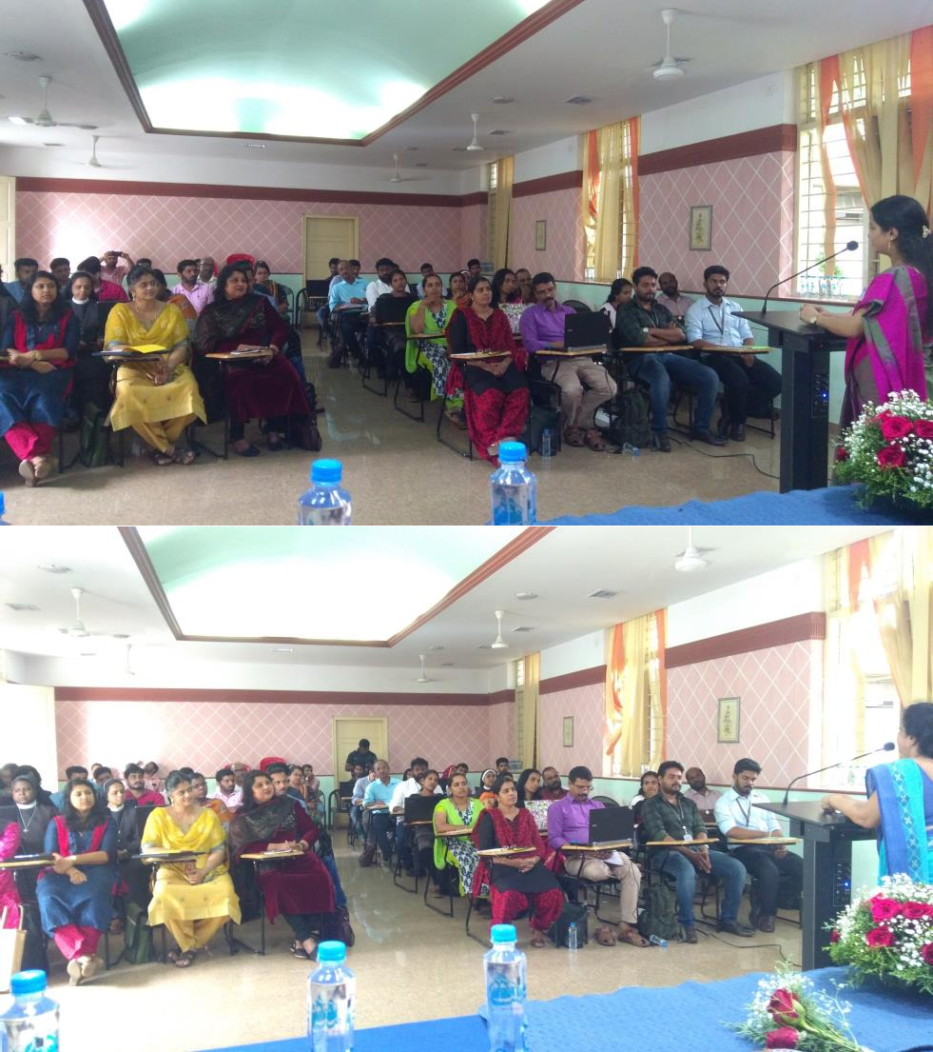
JOSH TALK -Teller talk 1- KNOW YOUR RIGHTS
Date: 8 August 2019
No. of Participants: 130
Venue: College Auditorium
Report:
Teller talks is an initiative of B. Voc Banking and Financial Service. It is a platform for the exchange of knowledge related to banks, capital markets, and other general topics. The first Teller talk series was jointly organized by the department of B. Voc Banking and Financial services and Department of B. Voc Tourism. The event was conducted in the college auditorium in association with Josh talks and Vivel company on the topic “KNOW YOUR RIGHTS” on 8 August 2019 at 2.00pm. Mrs. Stalin. P.C, Assistant Professor, Nodal Officer delivered a welcome speech. Ms. Avaneet Kaur, representative of CSR Research Cell, Vivel ITC group addressed 130 students of various departments and talked about the various rights of women laid in our constitution through an interactive presentation. The event was concluded with a vote of thanks by Mrs. Jijo Paul, Assistant Professor, Department of B.Voc Banking and Financial Services.
Objective : To make students aware of various rights and privileges in the constitution of India for women.
Outcome: This made the students, especially girls, have a better knowledge about their rights.

: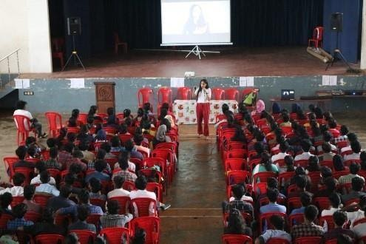
NATIONAL SEMINAR ON VOCATIONAL STUDIES
Date: 17thOctober, 2019.
No. of Participants: 60
Venue: Acoustic Theatre
Report:
Dr. Vivek Nagpal, Resource Person , RUSA Resource Center New Delhi delivered a talk on Vocational aspects of Skill Based courses for B Voc Banking and Financial Service Students and B Voc Tourism and Hospitality Management students at acoustic theatre on 17thOctober, 2019.
Objective : The seminar was organized to make students aware of the importance and scope of skill based education in this era.
Outcome : This seminar helped the students to get a clear understanding about the importance of vocational aspects of skill based education.

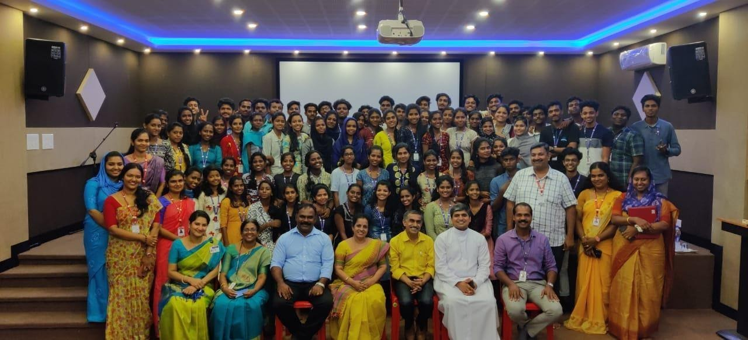

TELLER TALK 2 - APPLICATION OF IPR IN MUTUAL FUND INDUSTRY
Date: 13th November, 2019.
No. of Participants: 60
Venue: college seminar hall.
Report:
The second teller talk of B Voc Banking and Financial Services was conducted on the topic of the APPLICATION OF IPR IN MUTUAL FUND INDUSTRY. It was conducted on 13th November 2019 at college seminar hall. classes were taken by Shri Peter Thomas in associate with UTI Asset Management Company Limited.
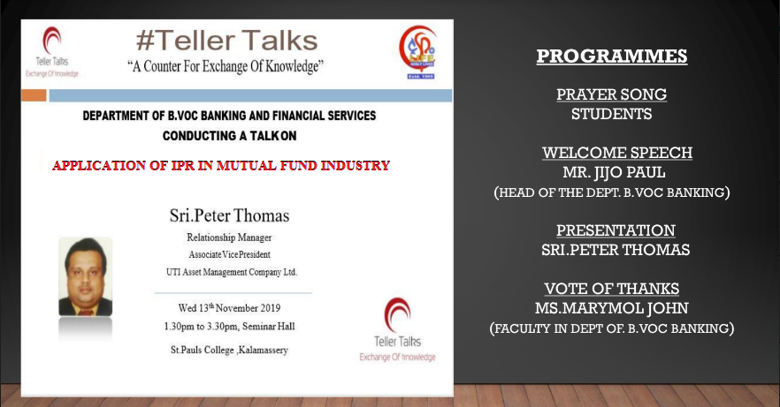

TELLER TALK 3 - INTELLECTUAL PROPERTY RIGHTS PROTECTION AND FINANCIAL MARKET

Date: 15th November 2019
No. of Participants: 65
Venue: college seminar hall.
Report:
A third Teller talk series of B Voc Banking and financial services was conducted on the topic Intellectual Property Rights Protection and Financial Market on 15th November 2019 at the college seminar hall. classes were taken by Sanil Kumar associated with acumen capital market Limited.
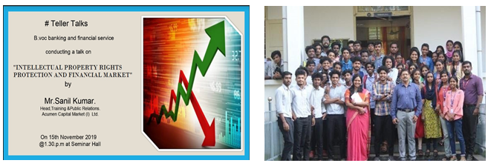

NATIONAL SEMINAR ON ENTREPRENEURSHIP TRENDS AND OPPORTUNITIES IN BANKING AND FINANCIAL SERVICES.
Date: 18th November 2019
No. of Participants: 65
Venue: college seminar hall.
Report:
B Voc banking and financial services conducted a National seminar on 18th November 2019. The seminar was conducted on the topic Entrepreneurship Trends and opportunities in banking and financial services. 165 students attended the National seminar. the department provided them with participation certificates. The resource persons for the seminar was Mr. Narayanan Namboothiri, Mr. UnniKrishnana and Mr, Dinesh, SBI Manager.

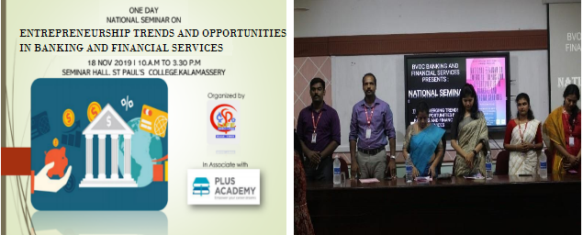

KERALA BUDGET ANALYSIS 2020
Date: 28 February 2020
No. of Participants: 65
Venue: college seminar hall.
Report:
On 28 February 2020, Along with our post-graduate department of Economics of St. Paul's College Kalamassery, B Voc Banking and Financial Service organized Analysis of Kerala budget 2020. Research Officer from the State Planning Office, Analyzed the Budget.

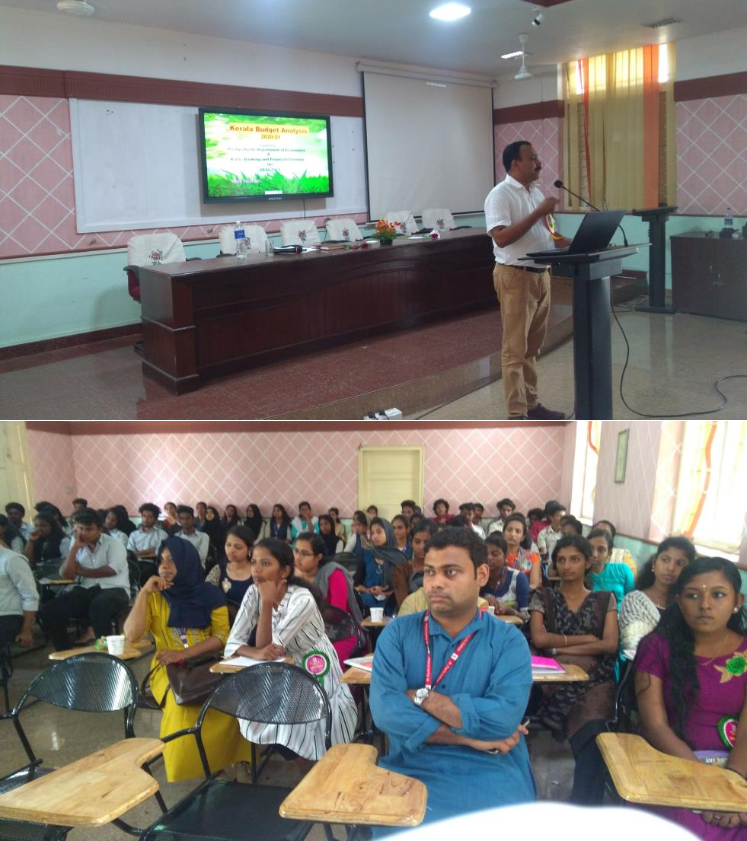

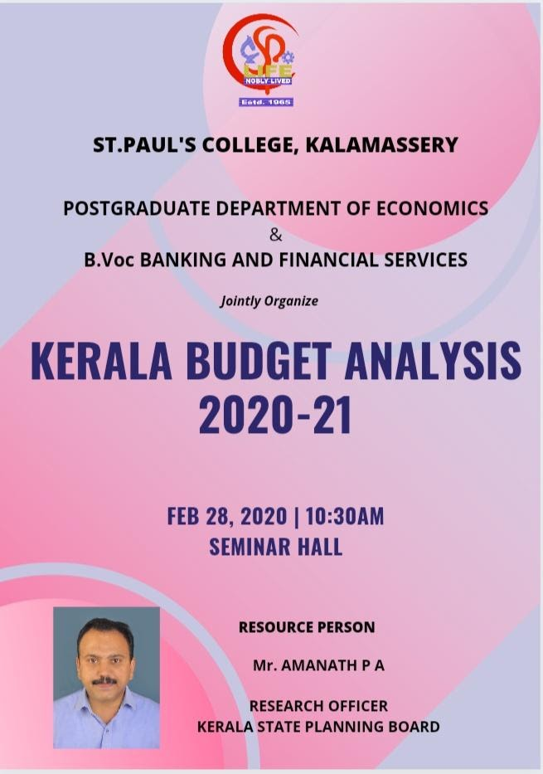
NATIONAL WEBINAR ON CAREERS IN BANKING AND FINANCIAL SECTOR- A POST COVID EFFECT
Date: 14 may 2020
No. of Participants: 125
Venue/Platform: Google Meet
Report:
The department of B.Voc Banking and financial services had conducted a national Webinar on Careers in banking and financial sector- a post Covid effect on 14 may 2020. The resource person of the webinar was Mr. Pradeep Chandrasekhar. He is an expert in Equity Research and Security Management. He has been in the field of capital market in 1991. Welcome note was given by Prof. Stalin P.C, Nodal officer of B.Voc. Dr.Asha E Thomas, IQAC coordinator of St. Paul’s College Kalamaserry inaugurated the webinar. More than 125 participants were there. Prof. Renuka Rajeev was the webinar coordinator. Duration of the webinar was two hours and it got wound up by a vote of thanks by Prof.Marymol John.
Document :
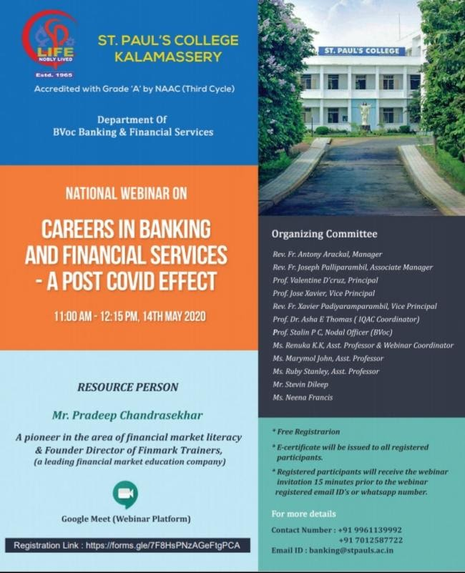
Student Outreach and Extension Programs by B.Voc Banking and Financial Services
Community Empowerment Program – Kudumbashree Visit(Extension)
2019-20
As part of the community empowerment programme, the Department of B.Voc Banking and Financial Service had organised an outreach program that facilitated our students to render an enlightening session on Mobile Banking awareness to self-help groups. This program was conducted in January 2020 focusing on five different panchayats of Ernakulam District. It was our proud privilege to take our students to the Kudumbashree units within the district and enable them to present sessions on trends and opportunities relating to the mobile banking realm.
The program was conducted by our second batch of students in the B.Voc program who had enrolled and joined our institution in the year 2019. They comprised a total of 50 students from the first year class. The class was broadly classified into 6 groups based upon which they were made to visit the chosen units. The criterion for categorization was the area of domicile of students. The interactive sessions conducted were aimed at covering the theme of micro finance from our curriculum by providing presentations on basics of micro finance.
During the interactive session, our students had addressed the audience on various emerging social issues and concerns. Our students had also trained the participants in simple yet effective skill oriented works like the making of paper bags, paper pens etc. The students had spent around 3-4 hours in the units. Subsequent to the visit our students had demonstrated in college the entire session taken via PowerPoint presentations.
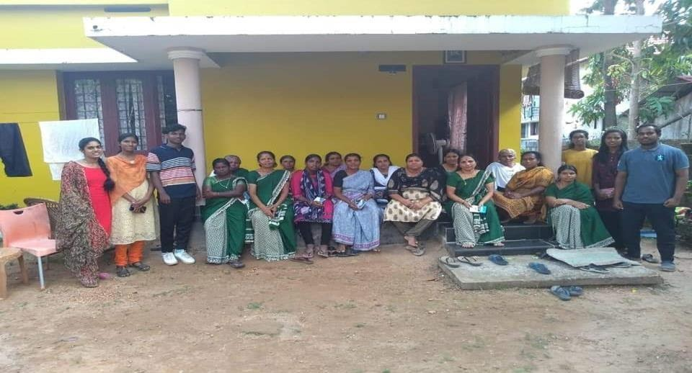
Philanthropic Program - Orphanage Visit(Outreach program)
In association with the Christmas celebration of our department, the faculty and students of B.Voc Banking and Financial Services had visited an orphanage named ‘Nirmala Shishu Bhavan’ located at Kaloor. This program was conducted in December 2019. It was an immense pleasure for us to get an opportunity to make a visit to the orphanage. It was held during an auspicious occasion of Christmas celebration in the orphanage.
The program was conducted by our second batch of students in the B.Voc program who had enrolled and joined our institution in the year 2019. They comprised a total of 50 students from the first year class. Ms. Marymol John and Mrs. Ruby Stanley were the two faculty members who had administered the visit and accompanied the students to the orphanage.
During the visit, our students had interacted with all the inmates of the orphanage. Our students had made it a point to entertain the inmates and staff of the orphanage with diverse extra – curricular activities. The students had showcased various performances like storytelling, playing games. It was also a good moment for our students to bring out their hidden talents like singing, dancing etc. Our students had distributed dresses, chocolates, toys, baby foods and other baby products for children. The department also undertook philanthropic activity by making generous cash donations. The program culminated by the cake cutting ceremony.
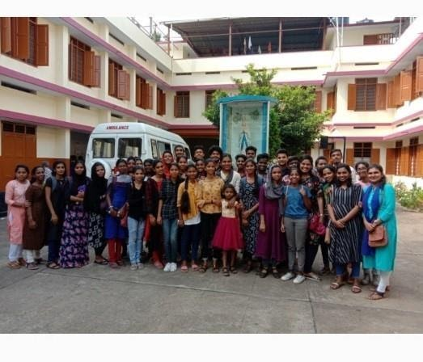

Kerala Flood Relief Activities

The flood which Kerala witnessed in 2019 brought misery to thousands of families. To mitigate the impact of the flood, the students B Voc Banking and Financial Services collected food materials and other required things for those who were staying at Refugee camps. 25 students and 2 teachers from B Voc Banking & Financial Services visited Kuttippuram Refugee camp at Manjapra and distributed 10000 rupees worth relief items.
