DEPARTMENT OF LOGISTICS MANAGEMENT
2021- 22

1.HERBA FESTA - WORLD ENVIRONMENT DAY

Date: 05.06.2021
No.of participants: 23

About the program
To commemorate World Environment Day, on 5th June 2021, Department of Logistics Management organized “Herba Festa”, an activity of planting varieties of medicinal plants at home. Teachers and students took part in the activity. We planted 25 herbs.

Faculty Coordinator: Amala Mathew
Student Coordinator: Shimron PT

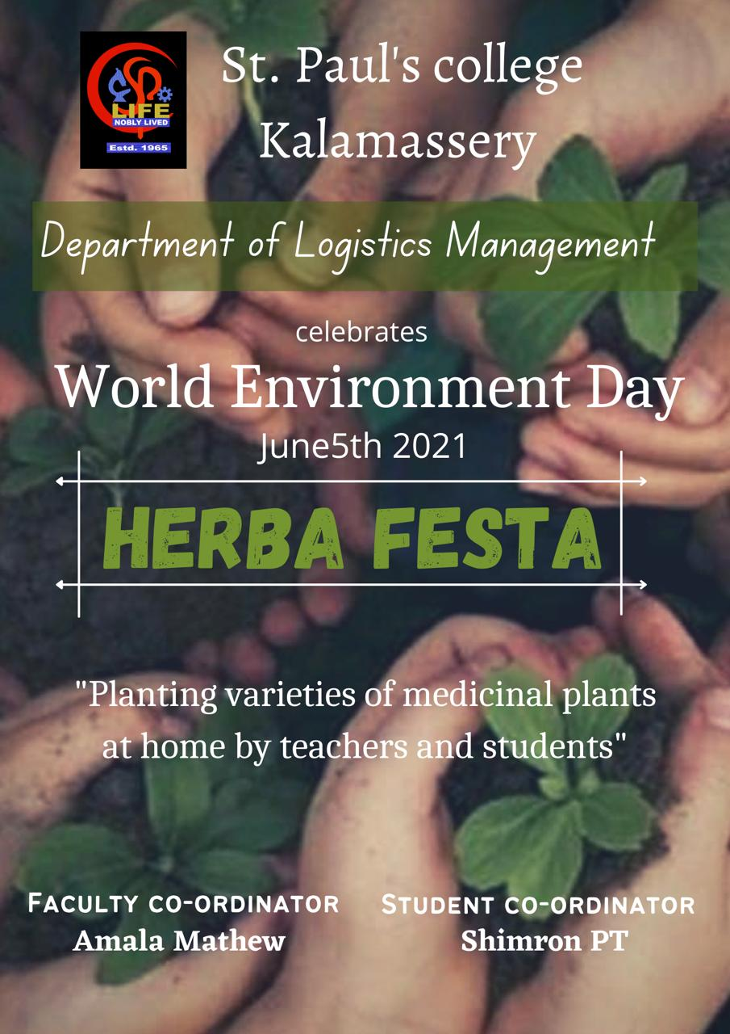

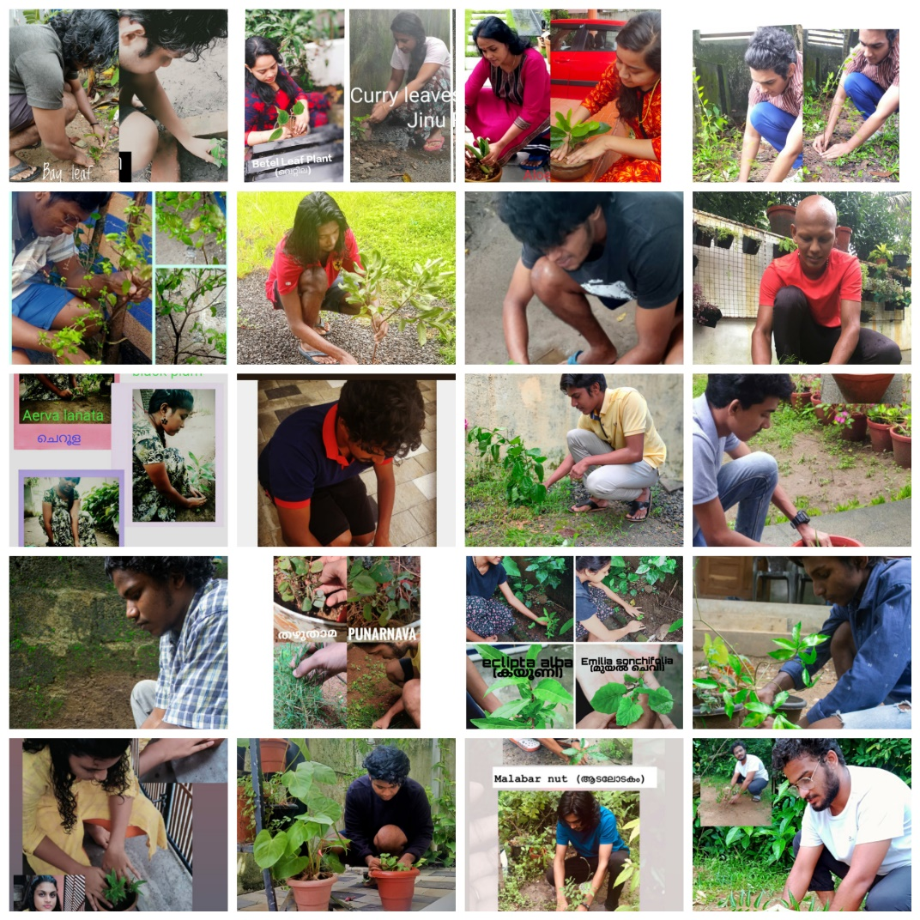

2.WEBINAR ON INCEPTION OF WAREHOUSE MANAGEMENT

Date: 14.06.2021
Platform: Google Meet
No. of participants: 68

A webinar on “Inception of Warehouse Management” was conducted on 14th June 2021 at 11.30am via Google Meet. Mr. Shajin P, Asst. Professor, DDU Kaushal Kendra, Cochin University was the resource person. The webinar focused on various concepts of Warehouse Management. There were 68 participants from various colleges.

Faculty Coordinator: Amala Mathew
Student Coordinators: Antony Rahul, Parvathy K.P
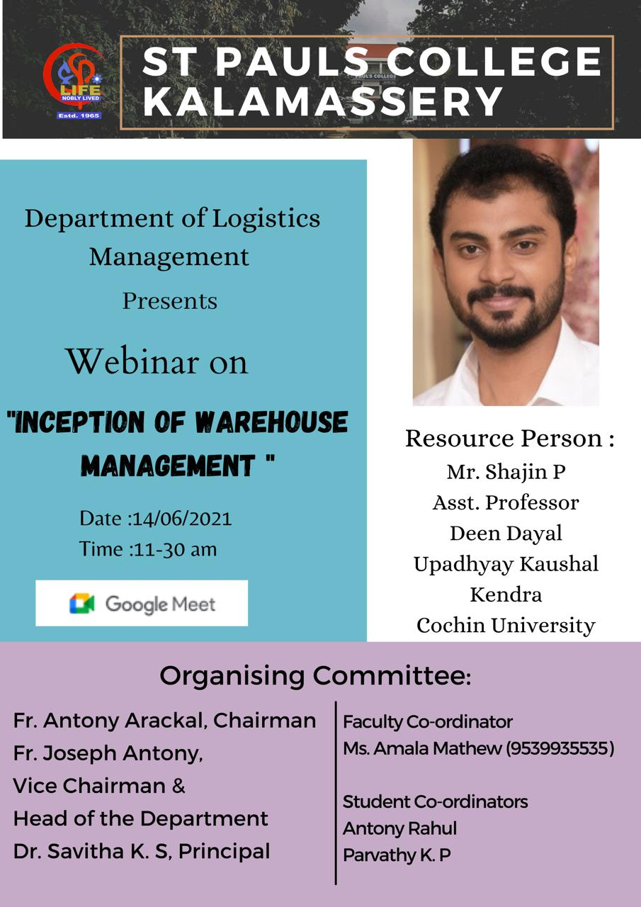

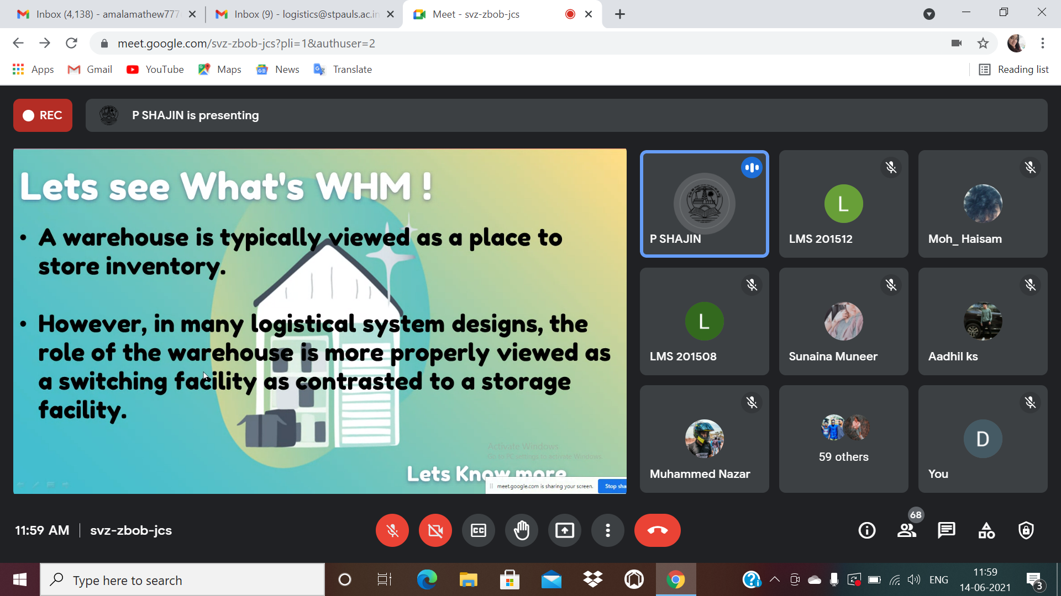

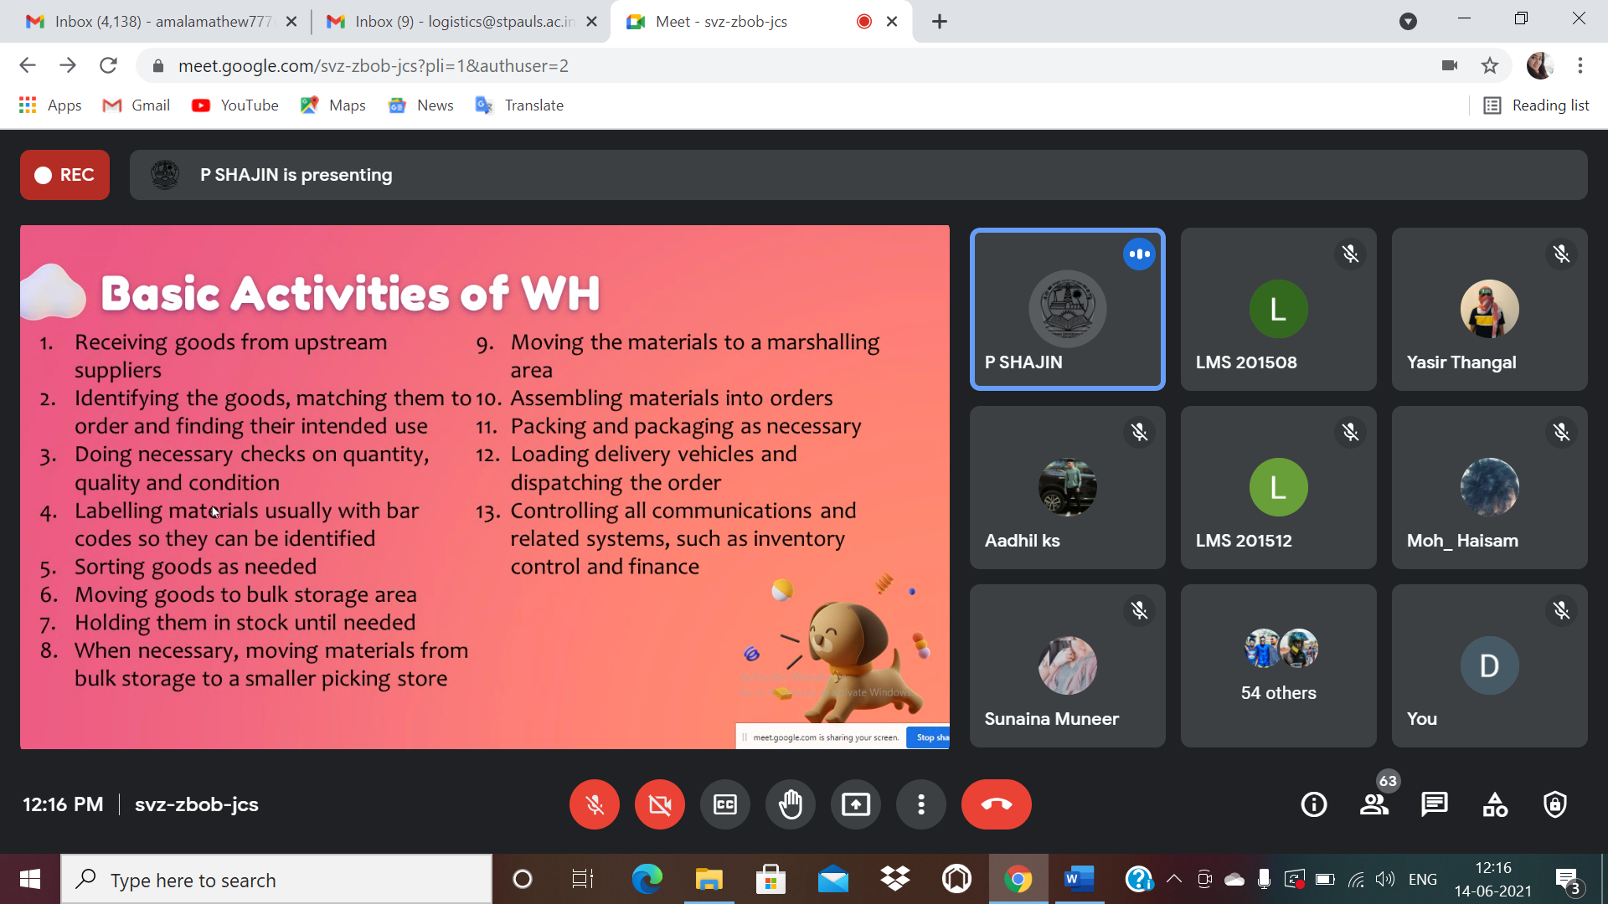

3.GREETINGS CARD COMPETITION

Date: 20.06.2021

To commemorate Father’s Day, on 20th June 2021, Department of Logistics Management organized Greetings Card Competition. Hand-made Greeting cards from various departments were received. Asna T.A of BA English (Aided) secured 1st prize and Aliya K.A of BVoc Banking secured 2nd prize.
Faculty coordinator: Amala Mathew
Student coordinators: Vishnu Nalinakshan

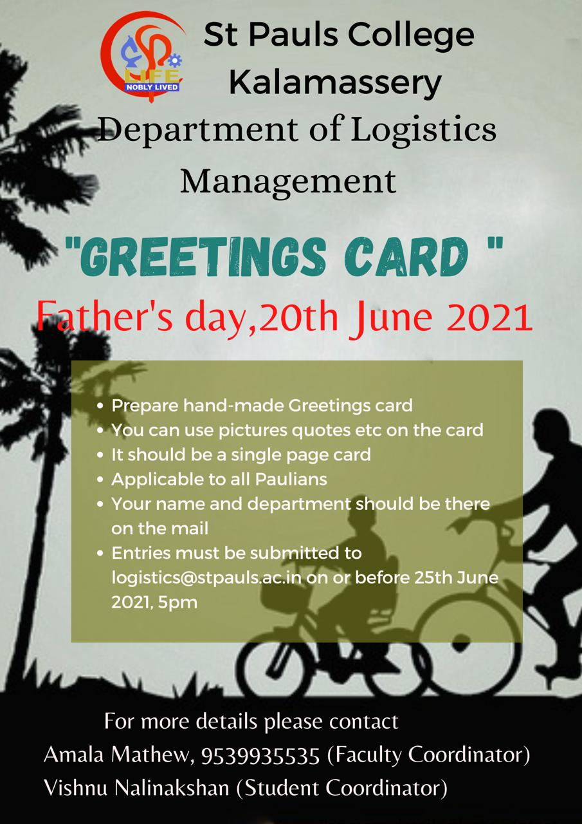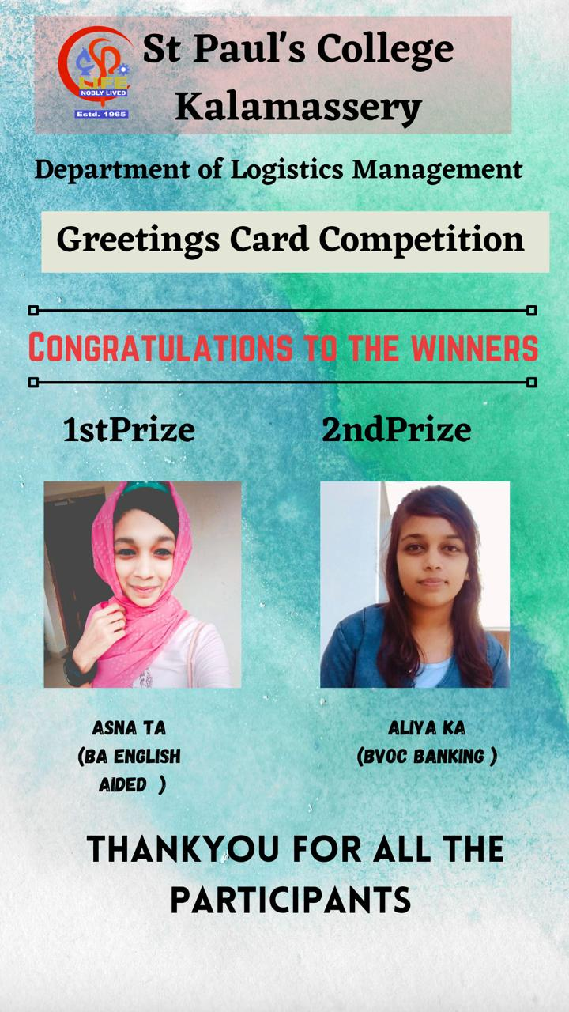

4.NATIONAL LOGISTICS DAY

Date: 28.06.2021

Department of Logistics Management celebrated National Logistics Day on 28th June 2021. A talk on “Exploring Logistics Management” was done by Mr. Anthony David, Loss Prevention Officer, Reliance Brands. 17 students of Bvoc Logistics Management participated in the program.

Faculty Coordinator: Amala Mathew
Student Coordinator: Abhijith M Mohanan

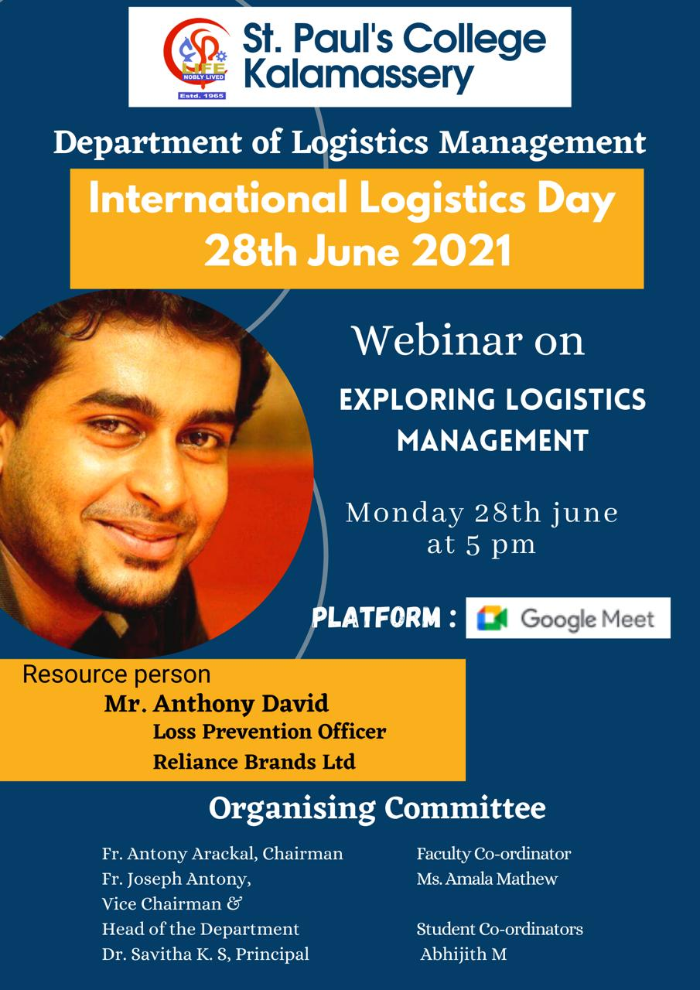

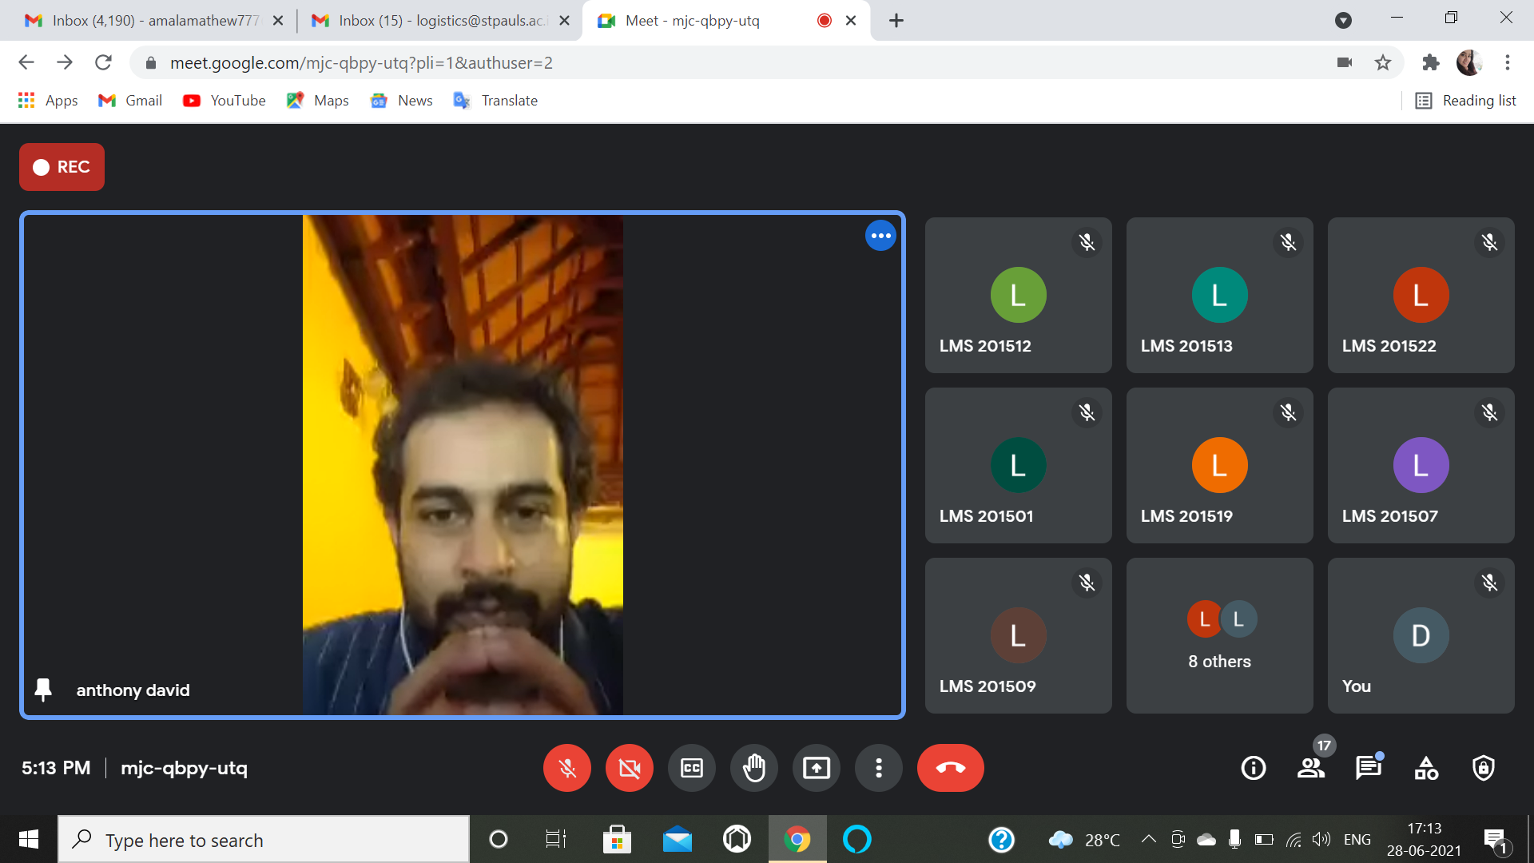

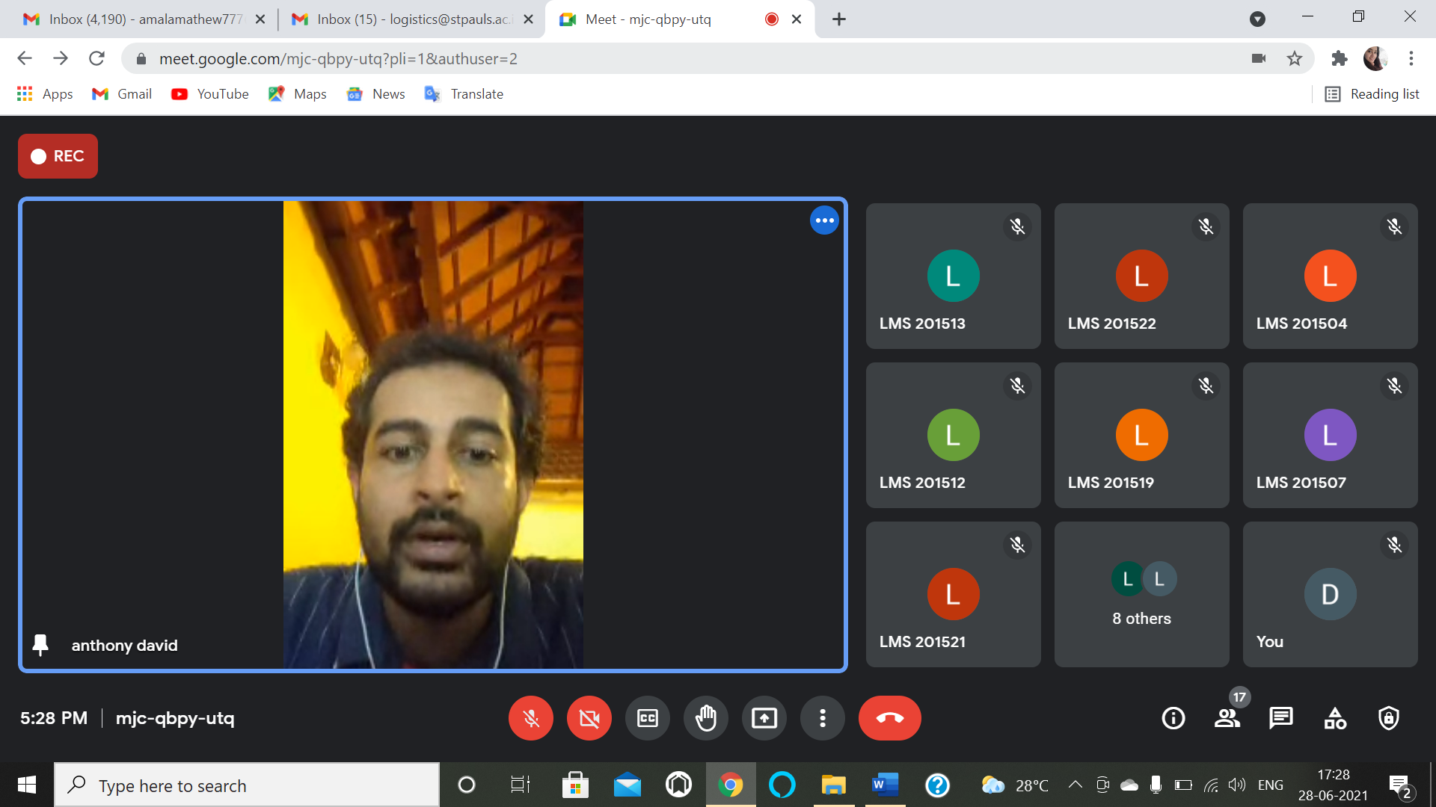

5.POETRY WRITING COMPETITION

Date: 15.08.2021

Department of Logistics Management celebrated Independence Day by conducting an inter departmental Poetry writing competition on the theme “Freedom”. 6 students from various departments participated in the competition.
Faculty Co-Ordinator: Amala Mathew
Student Co-Ordinator: Athul Kumar P A

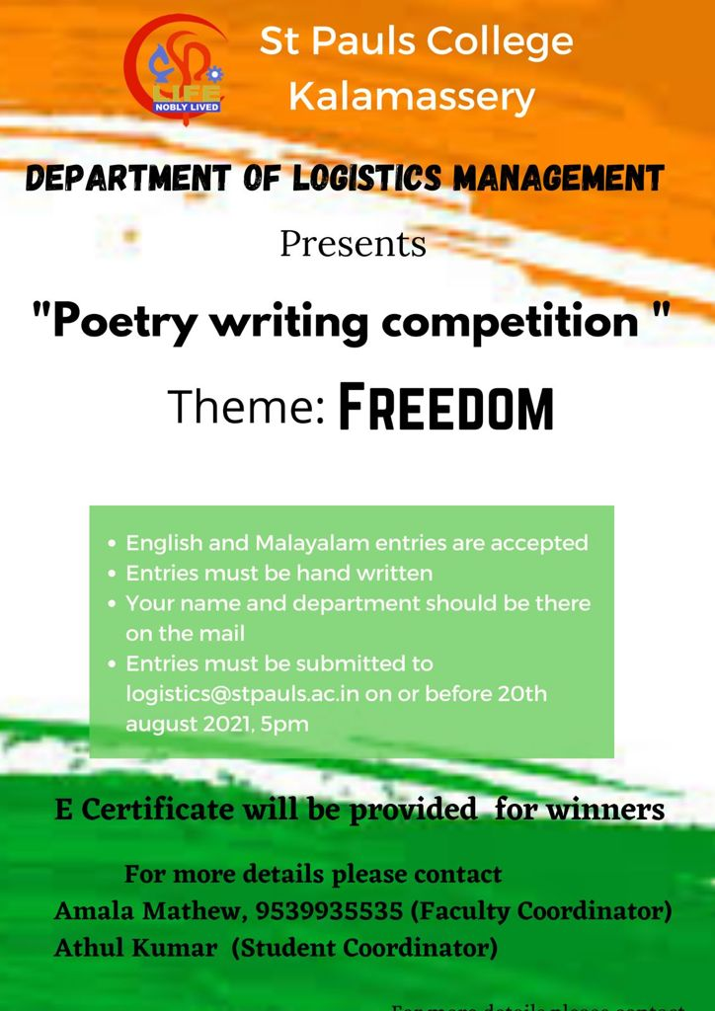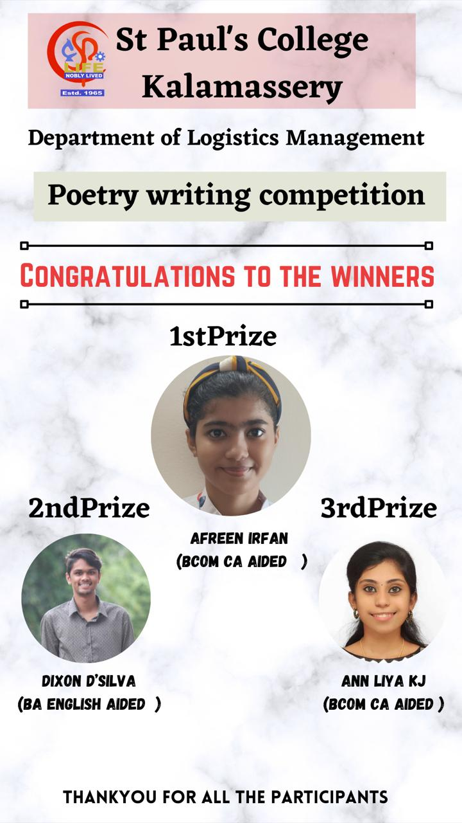

List of participants
Sl. No | Name of the student | Department
1 | Dixon D’Silva | BA English (aided)
2 | Afreen Irfan | BCom CA (aided)
3 | Ann Liya K J | BCom CA (aided)
4 | Sansia Gonsalves | BBA
5 | Parvathy K.P | BVoc Logistics Management
6 | Parvathy J | BBA

6.QUIZ COMPETITION

Date: 29.08.2021

As part of National Sports Day, Department of Logistics conducted Quiz competition for all the students of college. 87 students from various departments participated in the competition.

Faculty Co-ordinator : Jinu Rose
Student Co-ordinators : Shimron PT

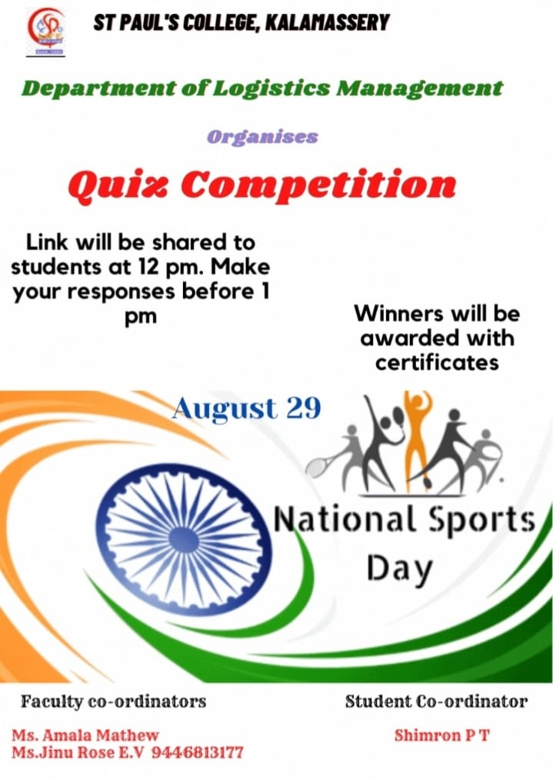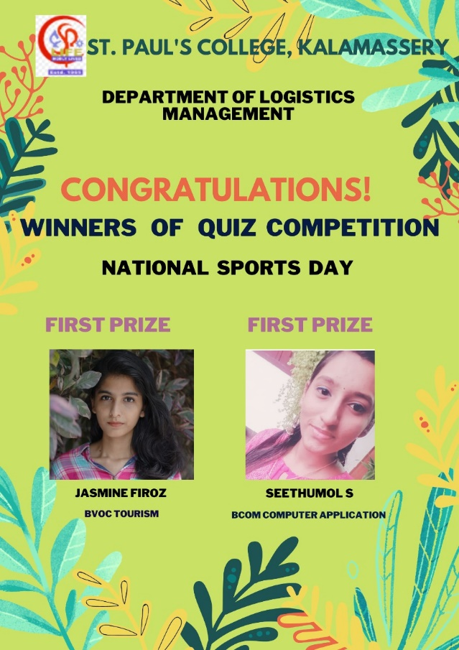

List of participants

Sl. No | Name of the student | Class ( Name of the programme & semester)
1 | Albert | Bvoc tourism and hospitality
2 | Ranjith Rajesh | B. Voc bfs, 2 nd year
3 | Jasmine Firoz | BVoc Tourism and Hospitality Management Sem-3
4 | Muhammed shohaib | 6 th sem b voc banking
5 | Muhammed Adil T N | B voc logistics sem. 2
6 | Siyan Fathima M S | 3rd Sem, B.Voc Banking And Financial Services
7 | Nabeel | B.voc logistics 1st sem
8 | Vidhyadhi Raja | BVoc logistics management
9 | Abhirami Venugopal T.V. | BBA 5th sem
10 | BIVEK KUMAR SINGH | BBA 3rd semester
11 | PRANAV K | LOGISTICS
12 | Abin Fayas | Bvoc logistics management
13 | SUMEESH S | B VOC BANKING AND FINANCIAL SERVICES &5
14 | Ashwin Suran | Bvoc BFS
15 | ATHUL KUMAR P A | Bvoc logistics management sem 3
16 | Albin George p.x | Bvoc banking and financial services { 3rd sem }
17 | Rajalakshmi K R | BVoc Banking and Financial Services , Third Semester
18 | Neial Jojo | 2nd year Ba English model 2
19 | Savitha.ks | B.voc banking and financial services 5th sem
20 | Krishnapriya k | BBA 5th sem
21 | Anisha Maria Job | II BA English Model II
22 | Aparna K M | BBA - 5 TH SEM
23 | Sandra nj | B. Voc banking and financial service -S3
24 | Calvin mammen john | B.voc tourism and hospitality management & semester-3
25 | ANN TREESA .M A | BBA semester 5
26 | Swathish | B voc tourism and hospitality management &3rd semester
27 | Asfiya ma | BBA 3rd semester
28 | Alshin D coutho | bcs201113@student.stpauls.ac.in, 3rdsem
29 | Keren Babu | BBA 3rd sem
30 | Sona K Varghese | B. Voc BFS, Sem 3
31 | Asna Ashraf | BA ECONOMICS (2 nd YEAR)3rd Semester
32 | Maneesh Dinakaran | B.Voc Banking and Financial Services, Sem-3
33 | ROSE P.M | BVOC BANKING AND FINANCIAL SERVICES sem -3
34 | POOJA B.M | 3rd Sem-B.voc Banking and financial services
35 | RITHIKA T GEORGE | B. VOC BANKING AND FINANCIAL SERVICES S3
36 | Sreehari s nair | BBA sem 5
37 | Srivinayak Aryan Aji | BBA 3rd
38 | Merrylmol Babichan | B.com Finance and Taxation (3rd semester)
39 | NEPT SUNNY | Bsc computer science
40 | albina gilbert | 3rd sem bvoc tourism and hospitality management
41 | Ebin George | Bsc computer science 3rd semester
42 | Sanjay R Menon | II Bcom finance and taxation 3rd sem
43 | Sayoojya M Biju | B.voc Banking and Financial services, 3rd sem
44 | ANNLIYA N J | BCOM CA AIDED (3rd semester)
45 | Parvathy J | Bba 3 sem
46 | Prasanth | B. Com tax 3 rd sem
47 | NEHA MARGRET | II B. COM FINANCE AND TAXATION (SEMESTER 3)
48 | Aneesh A T | BA - English, model 2 , 2nd year
49 | Anna Glinnis George | BA Economics 3rd semester
50 | Sayoojya M Biju | B. Voc Banking and Financial Services
51 | Siya Siju | B. Voc Banking and financial services, 3 semester
52 | Seethumol S | Bcom computer application aided third semester
53 | Aswin Mohan | B.voc Banking and financial services/6th semester
54 | Kenes Michael Kaduthuse | BA English m2 & 3rd
55 | Fathima Alfiya A A | BA Economics 2
56 | Ashwin Suran | Bvoc BFS
57 | Lalu.B | BA Economics
58 | Rohit. S | III BVoc Banking and Finance Services
59 | abhijith kv | Logistics management sem 2
60 | Sansia Gonsalves | Bba, 5th sem
61 | Remil Augustine Fernandez | BA Economics 3 rd semester
62 | Tony Saju | B.Voc Banking , S3
63 | Varsha Wilson | III BA English Model II, Vth semester
64 | Vishnu Nalinakshan | Bvoc logistics management sem-2
65 | Abhijith Vb | B.voc tourism and hospitality management
66 | Alen Sebastine | Bvoc tourism and hospitality management 3rd sem
67 | Anna Mariya saji | B.com ca aided 2nd year
68 | Sneha Subash | Tourism & Hospitality Management (third sem)
69 | Anjaleena | Bsc physics
70 | ANALD THOMAS | II BA ENGLISH MODELII
71 | Rahul N S | B.voc Logistics management
72 | Alan P Titus | B. Voc Tourism and Hospitality Management 3rd semester
73 | Shone Philips Thomas | BCom Computer Application Aided, 3rd Sem
74 | Mary Sheldreena Rodrigues | 2nd year bcom finance and taxation
75 | Jose Xavier | Physical Education
76 | Adithya Bai P | 2yr (Tourism And Hospitality Management )
77 | Ashraya prakash | B.voc tourism and hospitality management
78 | Suhaila ps | Ba economics /3rd sem
79 | Kavya K S | BA English Model II 3rd sem
80 | Niveditha Sajan | B. Voc banking,sem 3
81 | Prakash karki | Bvoc banking and financial services ,5th sem
82 | Evin Joseph George | III Bcom CA(aided)
83 | Elizabeth Shiron u j | Bcom computer application(aided)
84 | Reja Thahira | Bsc computer science 3rd sem
85 | Akshaya Mariya Ks | Bvoc Tourism and HospitalityManagement
86 | Dixon Dsilva | B.A. English modell II
87 | Appus prakashan | B. Voc banking and financial services 3rd semester

7. THE BEST STUDENT TEACHER

Date: 05.09.2021

As part of Teacher’s Day, department of Logistics Management organized an inter departmental competition called “The Best Student Teacher” which aimed to identify the students who is having excellent teaching skills. 6 students from various departments participated in the competition.

Facult Co-ordinator : Amala Mathew
Student co-ordinators : Muhammed Adhil, Parvathy K P

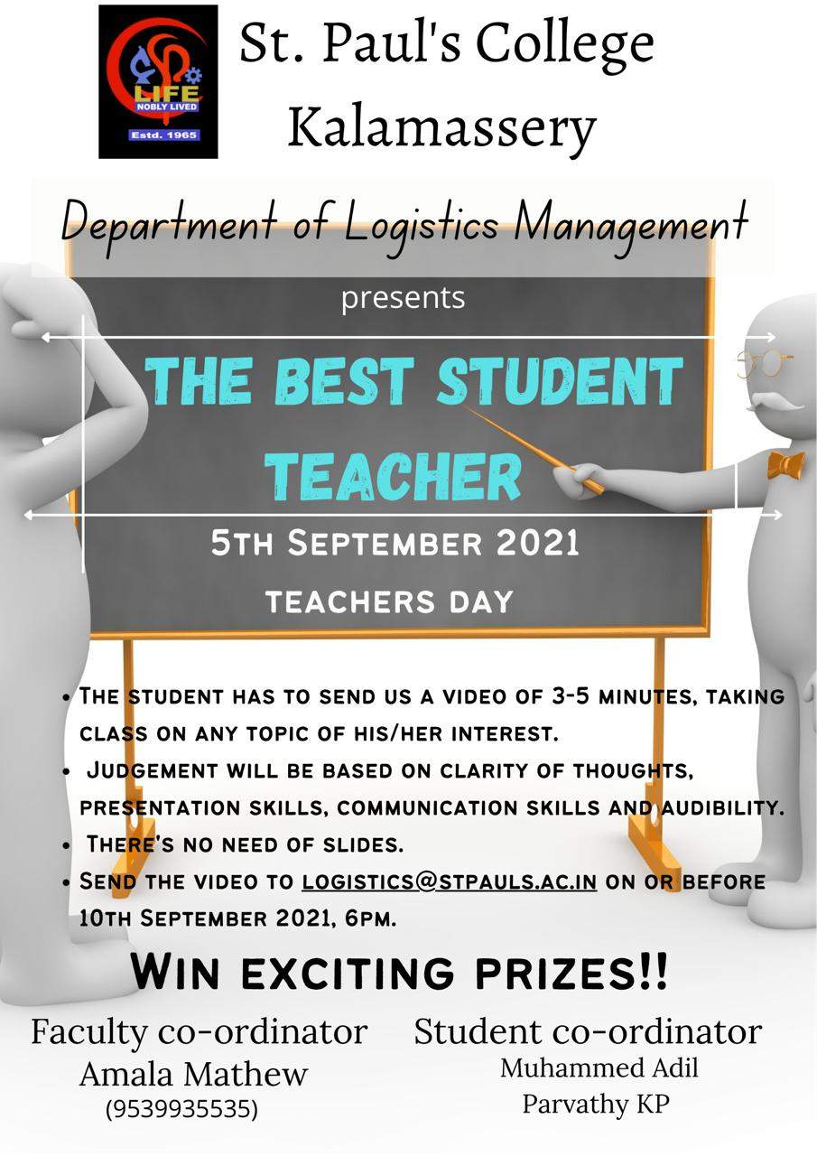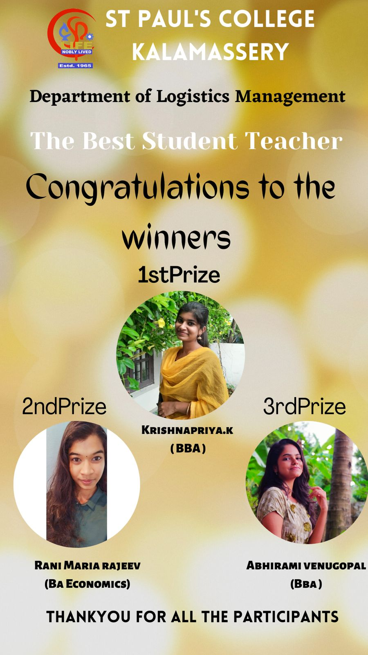

List of participants

Sl. No | Name of the student | Department
1 | Krishnapriya Balan | BA English
2 | Rani Maria Rajeev | BA Economics
3 | Krishnapriya K | BBA
4 | Abhirami Venugopal | BBA
5 | Sandra R | BBA
6 | Akshaya Maria K S | BVoc Tourism & Hospitality Management

8. SCHOLA BREVIS - WEBINAR ON EXPLORING LOGISTICS

Date : 30.09.2021
Resource Person: Dr. Suby K S
No. of participants: 48

About the program
As part of Deeksharambh 2021, a webinar on “Exploring Logistics” was organized by Dept of Logistics Management for the batch 2021-24, on 30th September 2021 through Google Meet at 10:30am. Ms. Amala Mathew, Faculty Coordinator, BVoc Logistics Management, welcomed the gathering. Dr. Suby K.S, Nodal Officer, Nirmala College Muvattupuzha was the resource person. Joy Jose, student of S1 Logistics delivered the vote of thanks.

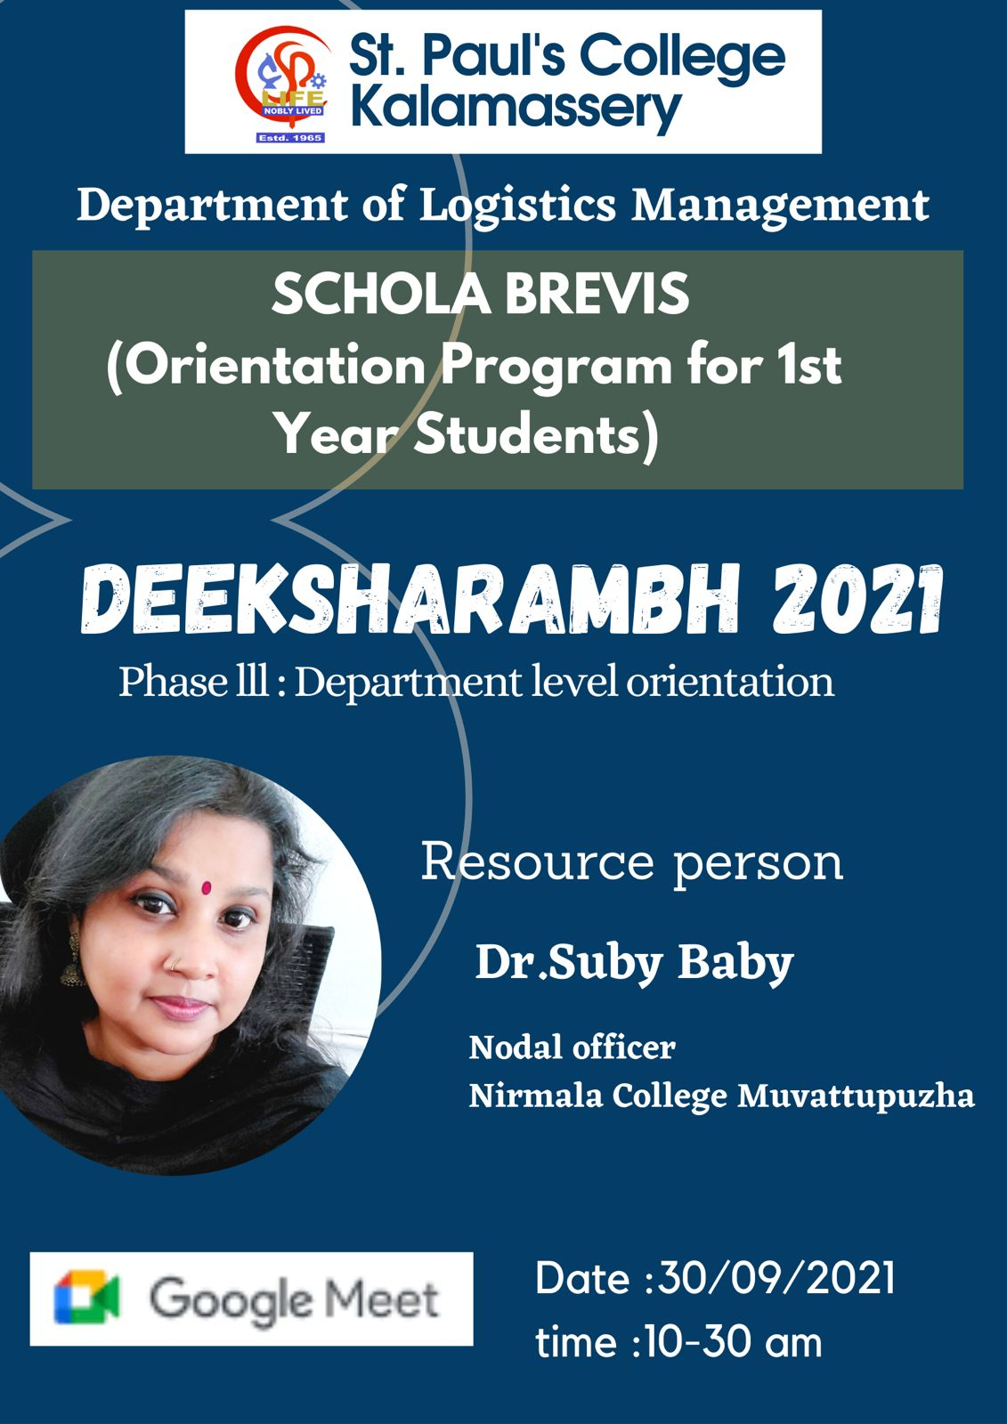

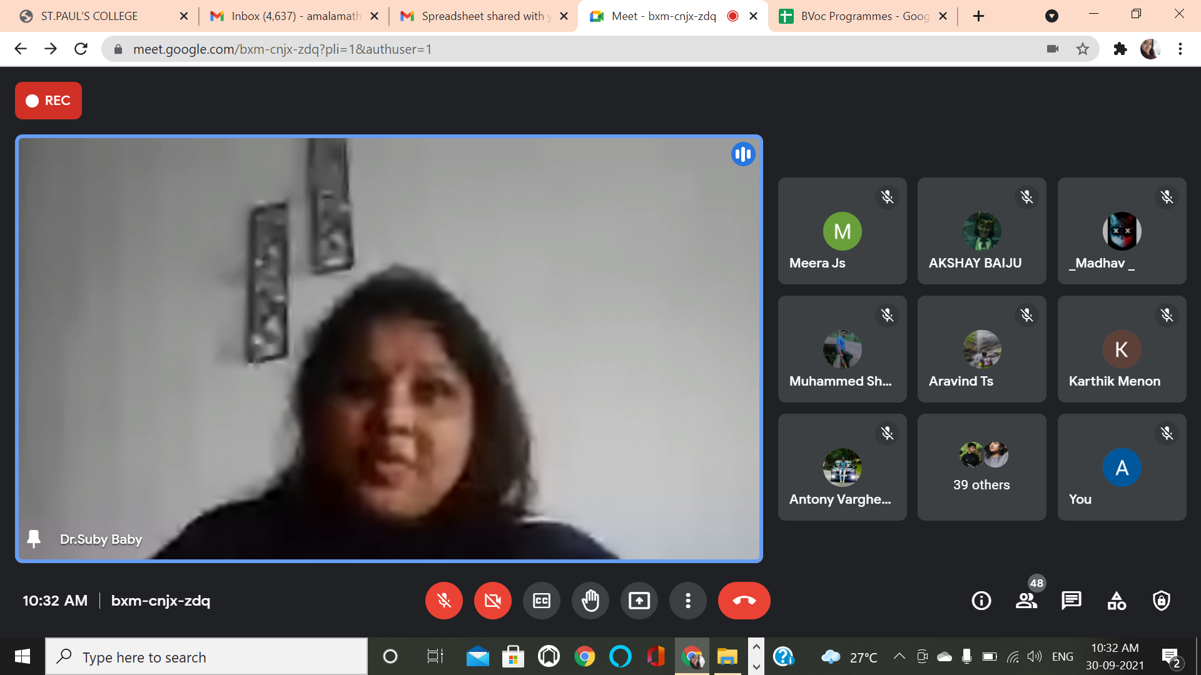

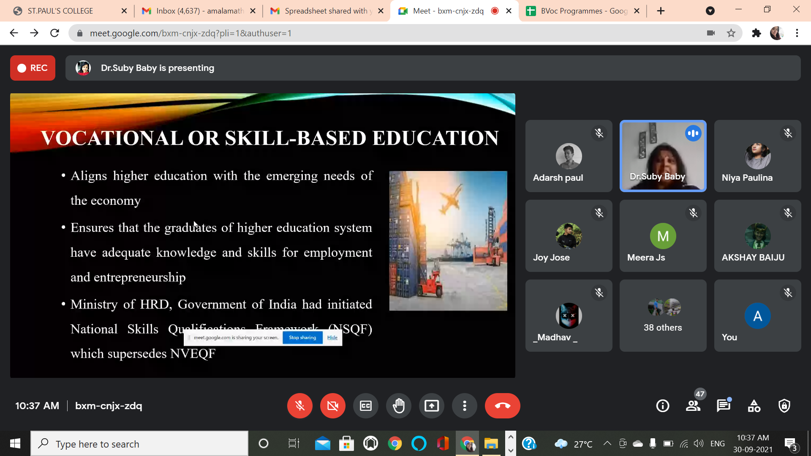

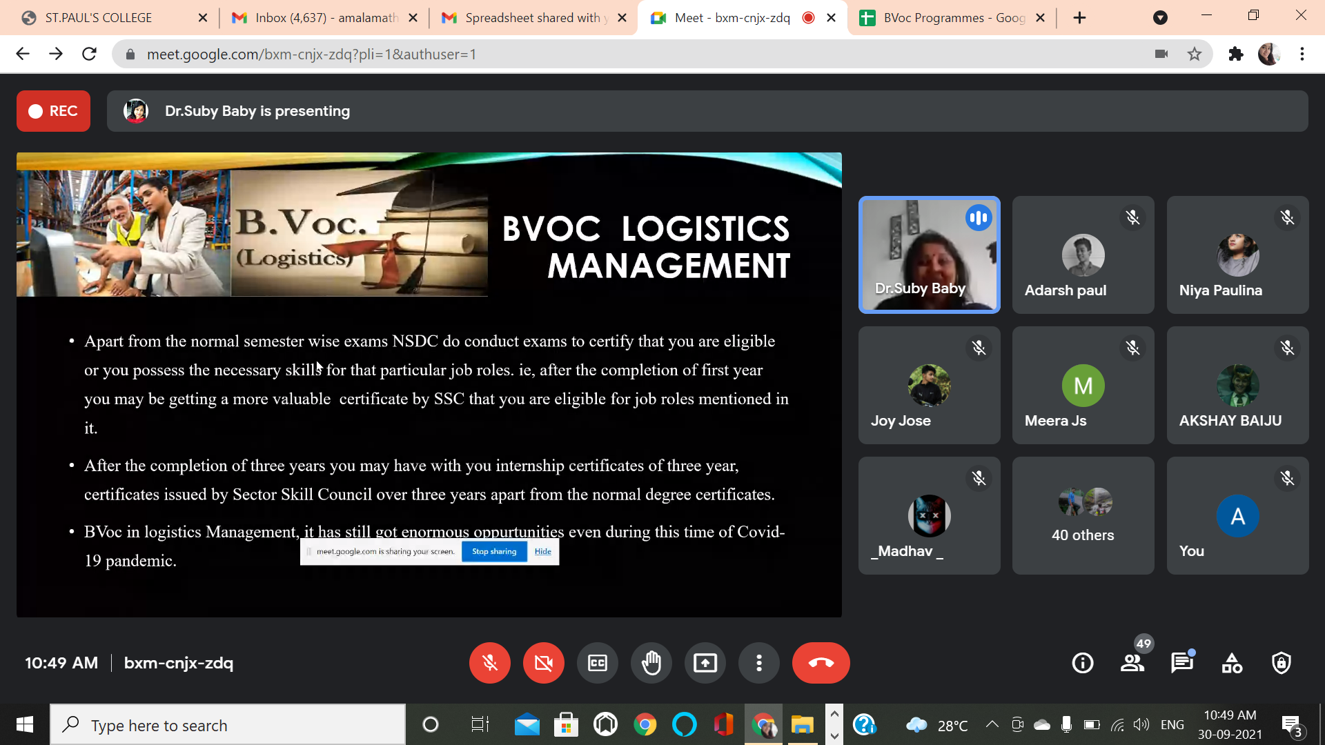

Sl.No | Name of the student
1 | ANUJITH S
2 | MARY ASHNA K.F
3 | AVINASH KUMAR A P
4 | AJEESH
5 | KARTHIK MENON R
6 | RONALD SIJI
7 | JESNA MARIA M A
8 | ALBIN DAVID
9 | CHRIS LLOYD PHILIP
10 | VARUN SAJEEV
11 | DONNA KALLARACKAL
12 | ABHIJITH A NAIR
13 | ARSHAD KABEER
14 | MEERA J S
15 | JENNIFER SOZA
16 | MUHAMMED SHAFI K J
17 | M. ATHUL KRISHNA
18 | V MADHAV
19 | AL HAD HUSSAIN
20 | ADARSH PAUL
21 | LEEVON JOSEPH
22 | AHARON K C
23 | AVANEENDHRAN V
24 | JOY JOSE PAYAPPILLY
25 | NIYA RAJESH
26 | ABHINAV SHINE
27 | JOYAL JOBY
28 | ALDON JOSE
29 | ANTONY VARGHESE
30 | NIBIN BAINS
31 | JEFRY GEORGE
32 | KELVIN N.S
33 | ALTHAF RAFEEK
34 | STEVE BENNY
35 | ABHIRAJ P R
36 | REMIN KS
37 | ALPHIN JOSEPH P
38 | ANSON VARGHESE P.S
39 | ALBIN XAVIER
40 | ARAVIND T S
41 | ALEXANDER JOJU
42 | AMAL KRISHNA N.J.
43 | GAUTHAM SHAJI
44 | ANTONY LIJO N A
45 | AKSHAY BAIJU
46 | SANTO BENNY
47 | AMAL SHAJAN
48 | JUDE TOLAMIN VINCENT

9. SCHOLA BREVIS – WEBINAR ON SELF AWARENESS

Date: 1/10/2021
Platform: Google Meet
Participants: 46

About the program
Department of B.Voc Logistics Management conducted a Departmental Level Orientation Program about “Self-Awareness” on 01st October 2021 at 11am through Google Meet. Asst. Professor Sreedevi Malappurath welcomed the gathering. Ms. Neenu Jose, HOD, Logistics Management, St. Albert’s College, Ernakulam was the resource person. Ms. Jennifer Soza, student from the class, proposed the vote of thanks.

Outcome of the program
Students were able to understand the concepts of self-awareness and its importance in recognizing primary coping mechanisms. It was an interactive session and the students cleared their queries on the relevance of defining one’s beliefs without being influenced by others for achieving joy.

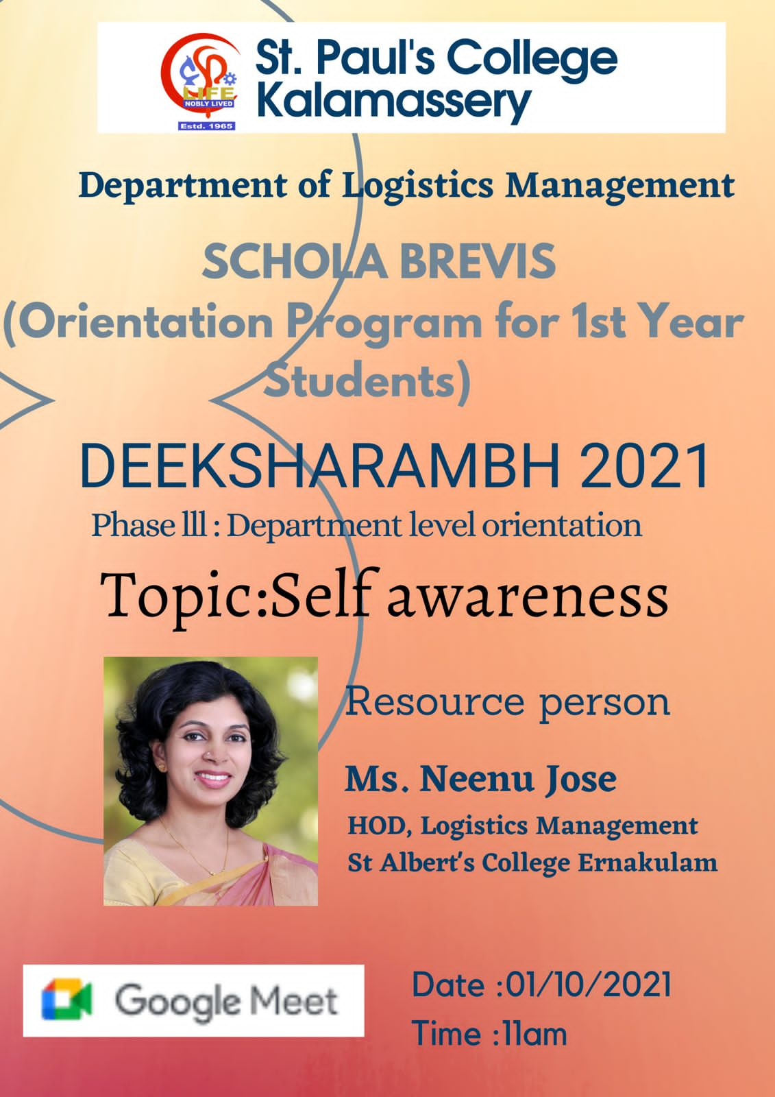

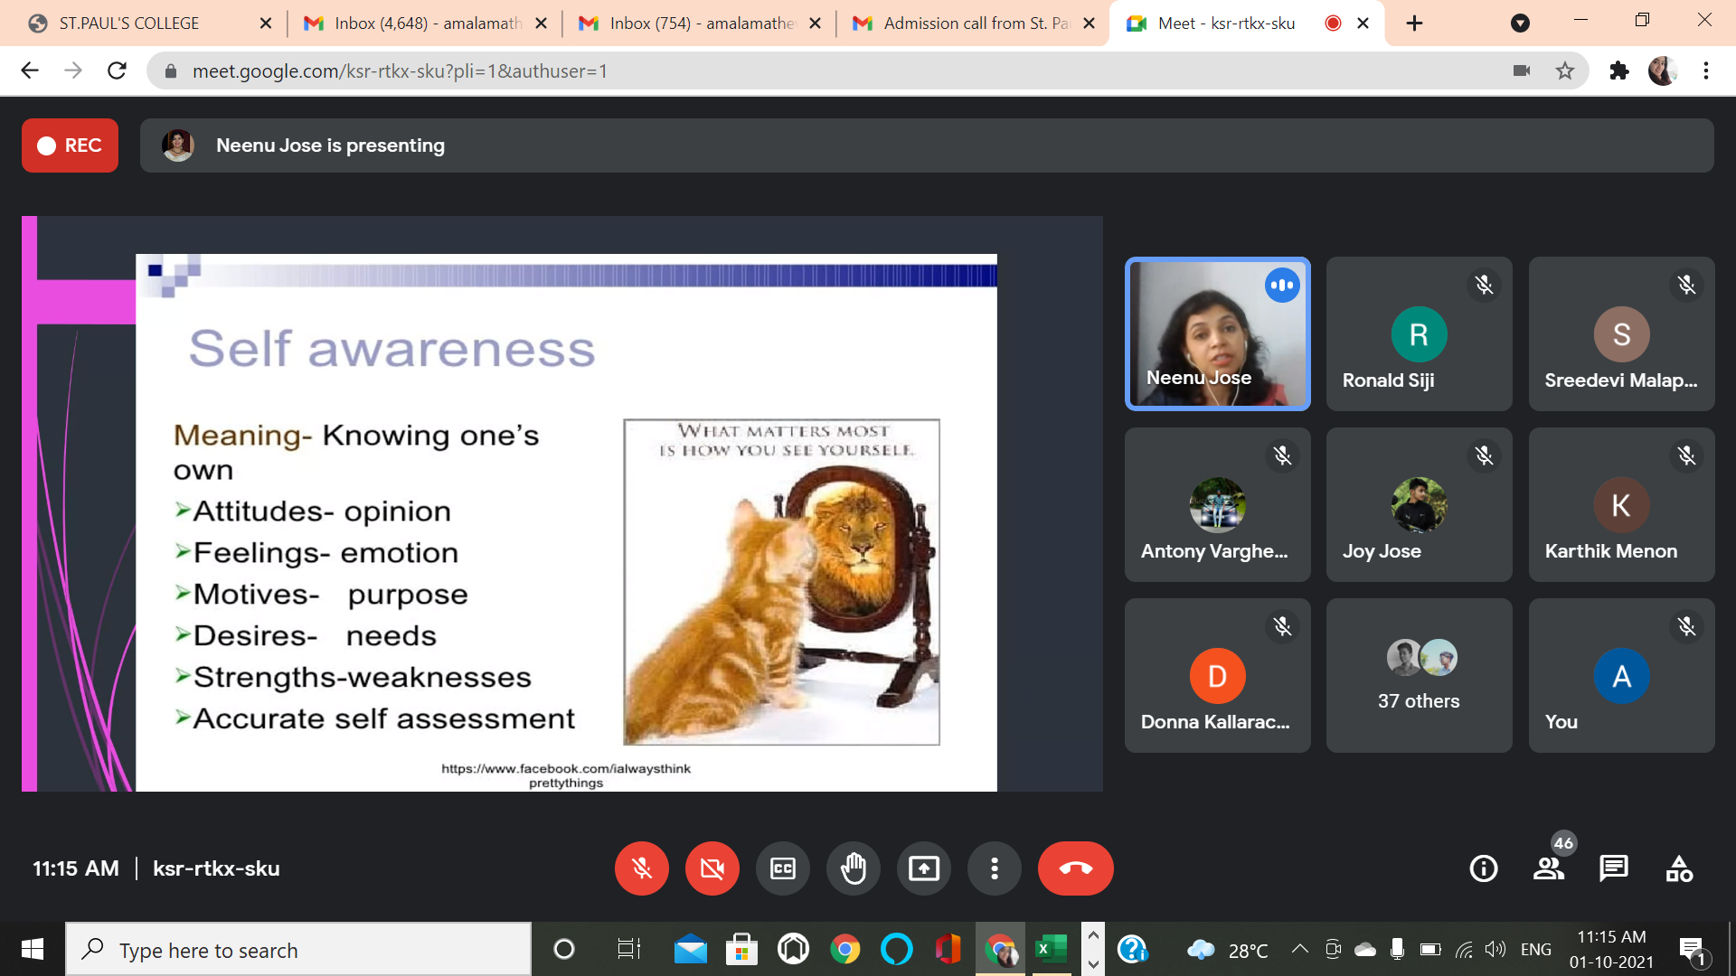

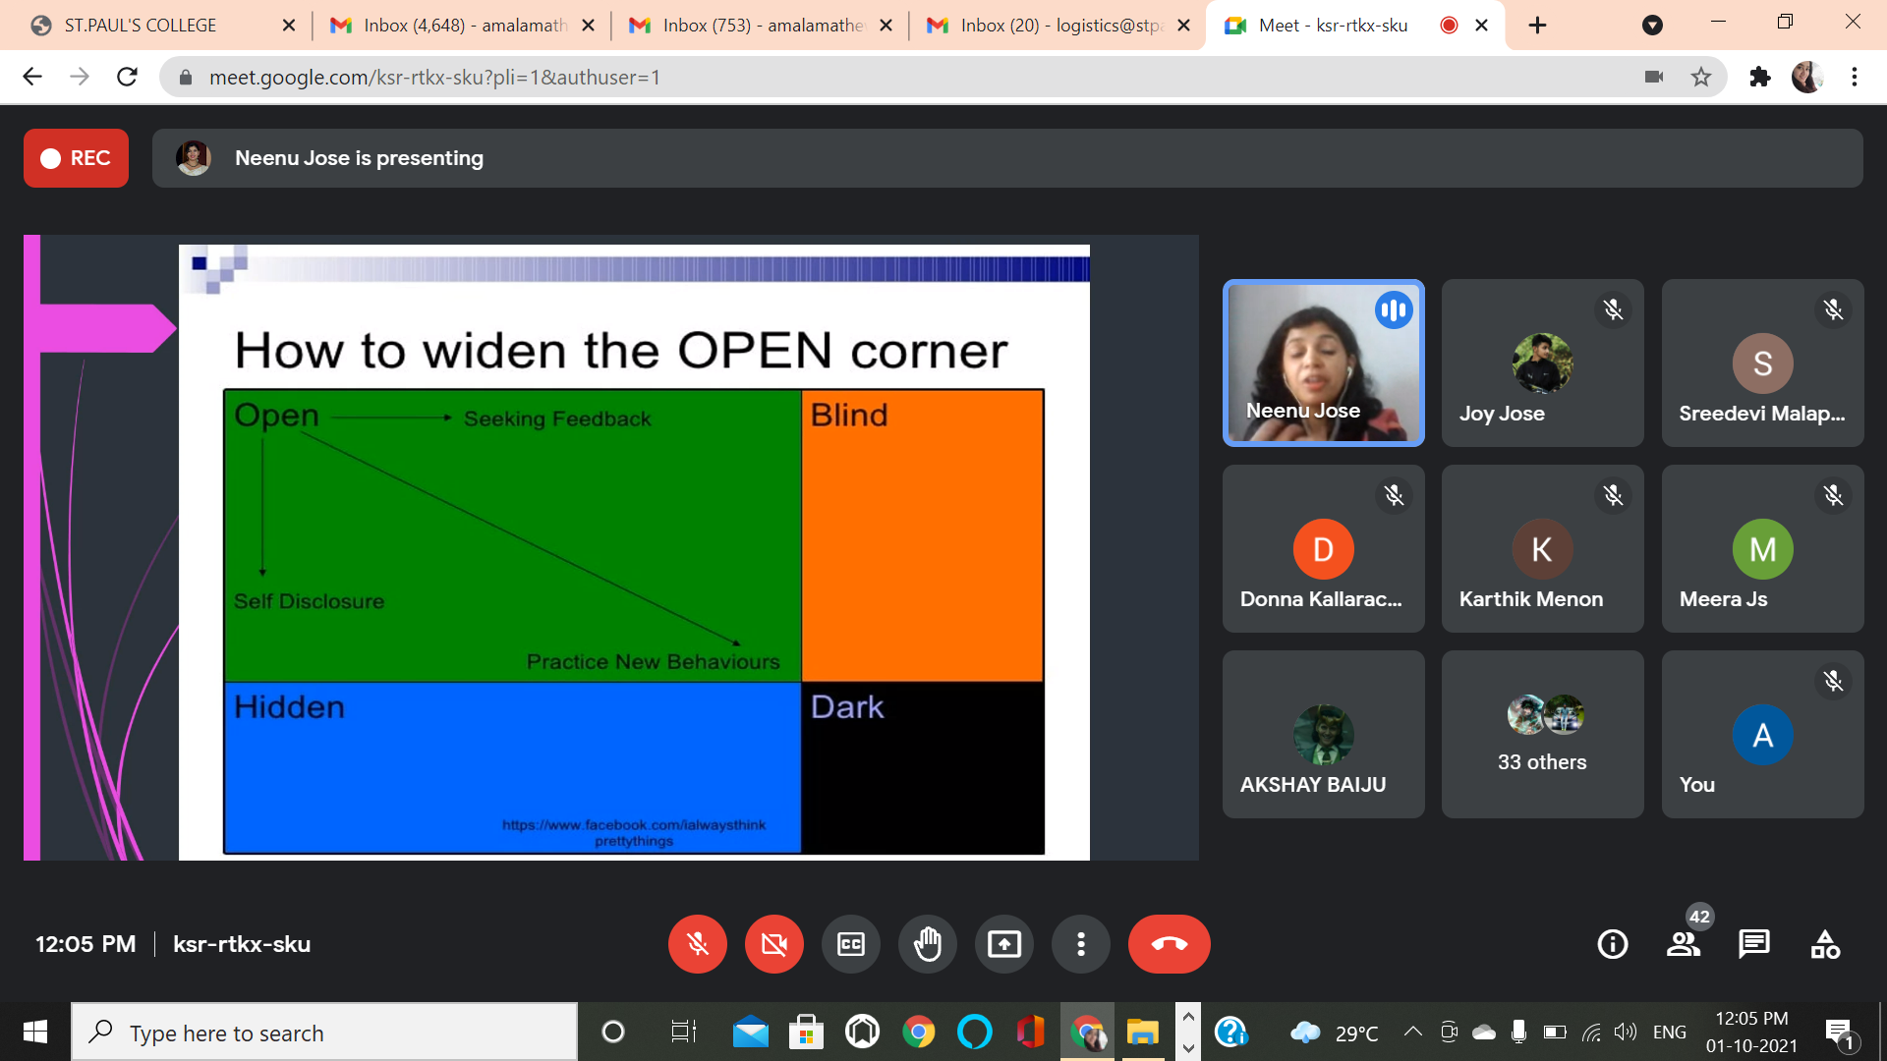

Sl.No | Name of the student
1 | ANUJITH S
2 | MARY ASHNA K.F
3 | AVINASH KUMAR A P
4 | AJEESH
5 | KARTHIK MENON R
6 | RONALD SIJI
7 | JESNA MARIA M A
8 | ALBIN DAVID
9 | CHRIS LLOYD PHILIP
10 | VARUN SAJEEV
11 | DONNA KALLARACKAL
12 | ABHIJITH A NAIR
13 | ARSHAD KABEER
14 | MEERA J S
15 | JENNIFER SOZA
16 | MUHAMMED SHAFI K J
17 | M. ATHUL KRISHNA
18 | V MADHAV
19 | AL HAD HUSSAIN
20 | ADARSH PAUL
21 | LEEVON JOSEPH
22 | AHARON K C
23 | AVANEENDHRAN V
24 | JOY JOSE PAYAPPILLY
25 | NIYA RAJESH
26 | ABHINAV SHINE
27 | JOYAL JOBY
28 | ALDON JOSE
29 | ANTONY VARGHESE
30 | NIBIN BAINS
31 | JEFRY GEORGE
32 | KELVIN N.S
33 | ALTHAF RAFEEK
34 | STEVE BENNY
35 | ABHIRAJ P R
36 | REMIN KS
37 | ALPHIN JOSEPH P
38 | ANSON VARGHESE P.S
39 | ALBIN XAVIER
40 | ARAVIND T S
41 | ALEXANDER JOJU
42 | AMAL KRISHNA N.J.
43 | GAUTHAM SHAJI
44 | ANTONY LIJO N A
45 | AKSHAY BAIJU
46 | SANTO BENNY

10. SEMINAR ON “INTRODUCTION TO LOGISTICS MANAGEMENT” AND “INTERVIEW SKILLS &TECHNIQUES”

Date: 30-03-2022
Venue: BACCINELLI Hall
Total no. of participants: 55

A Seminar on “Introduction to Logistics Management” and “Interview Skills and Techniques” was conducted on 30th March 2022 from 9.00 a.m. to 12.30 p.m. at Baccinelli Hall, St.Pauls College, Kalamassery. Dr. Jose Paul, Lead Consultant and Master trainer in Logistics and SCM was the chief resource person. The first session focused on various concepts of Logistics Management and industrial applications of the same. The second session was handled by Prof. Asha Sebastian, Faculty, Placement Coordinator, Soft Skills and Personality Development Trainer in Ibis Academy for Higher Education. The session imparted knowledge on various skills and techniques required to face an interview.
There were 55 student participants from the logistics department.

Faculty Coordinator: Ms. Sreedevi Malappurath & Mr. Robin V Raphy
Student Coordinators: Gautham Shaji

Seminar Brochure:-
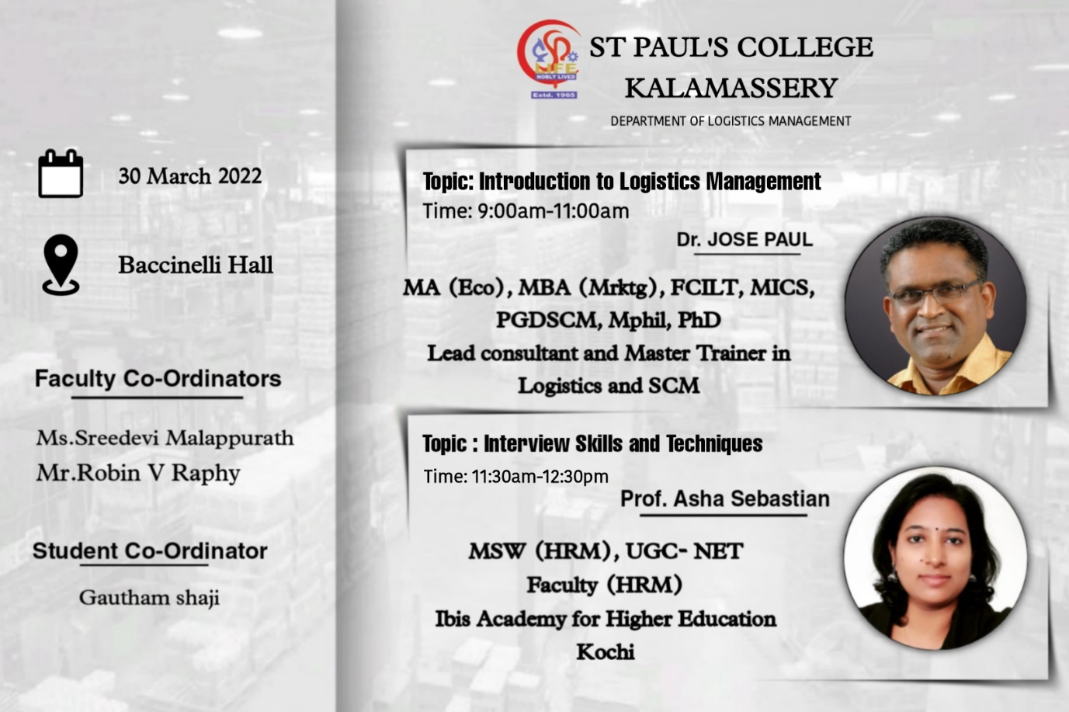

The event

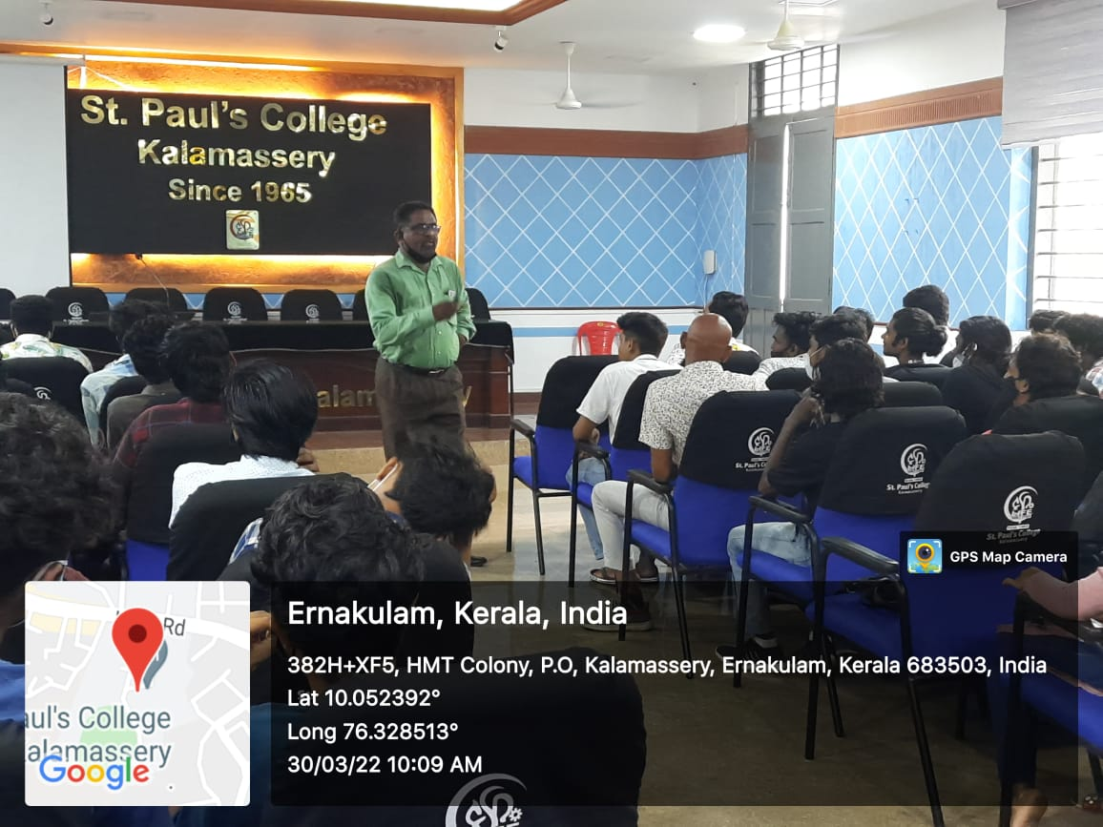
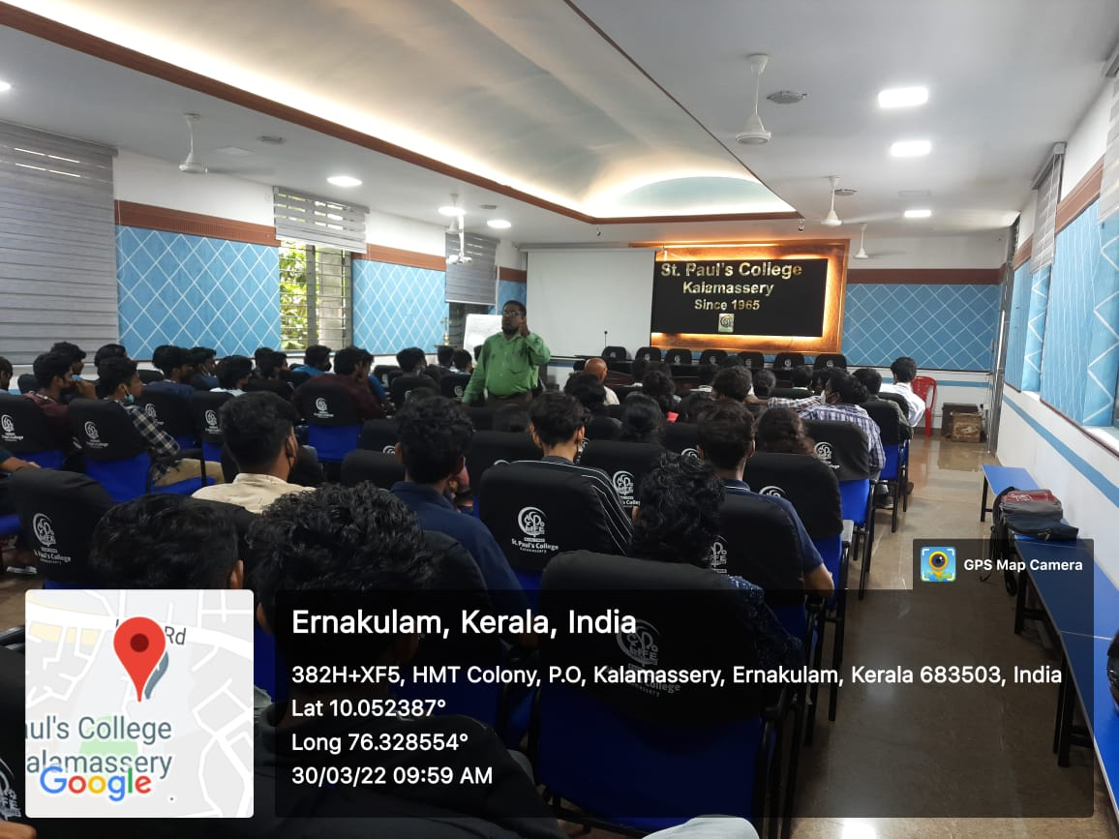

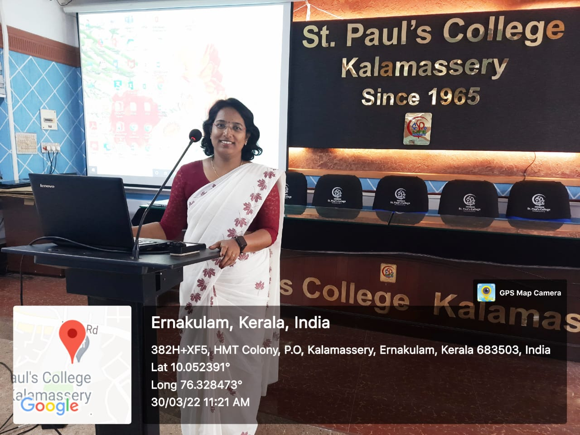

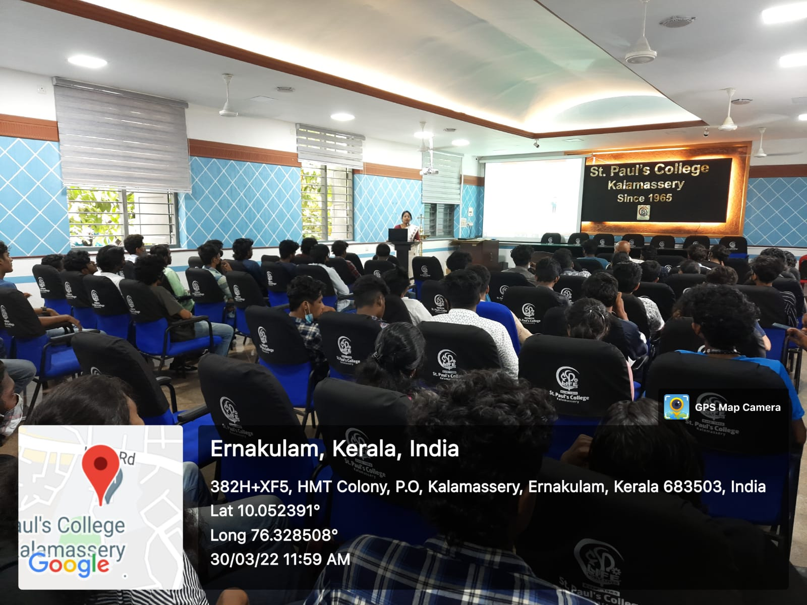

List of Participants

