READING DAY CELEBRATION-2021

In collaboration with Department of Malayalam, English and Hindi, St. Paul's College, Kalamassery, organized ‘Reading day celebration' Webinar programme on 19th June 2021.
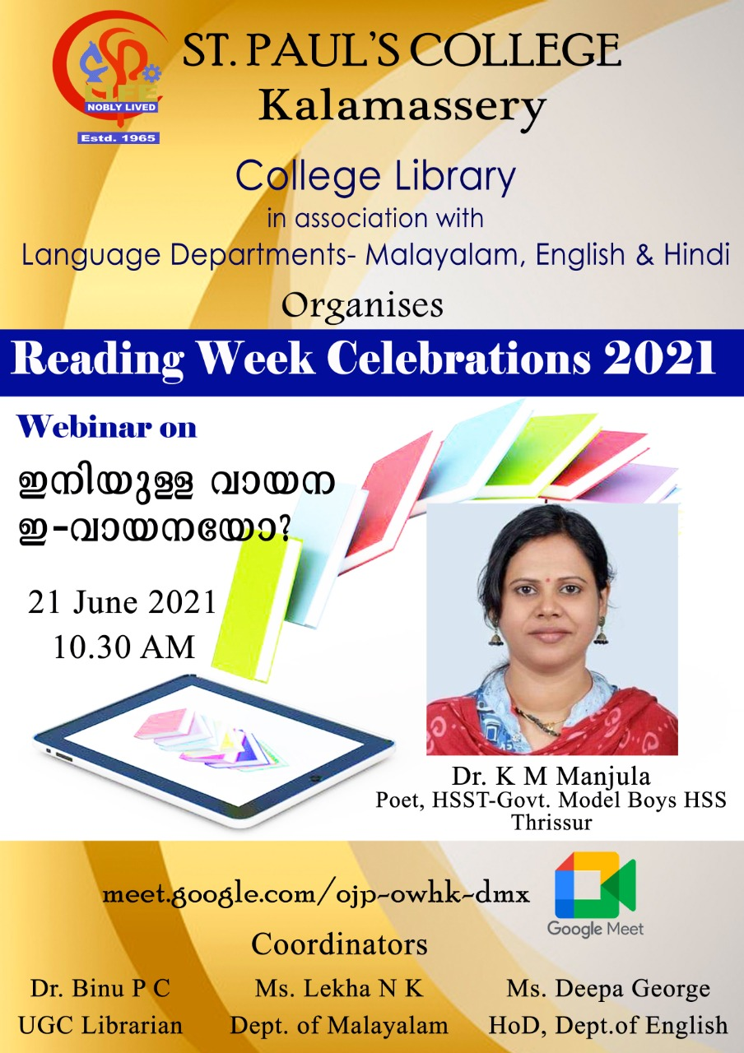

141st Birth Anniversary of Premchand - 2021

In connection with the 141st Birth anniversary celebrations of Munshi Premchand, the Department of Hindi organized a ‘Speech Competition on Literature of Premchand’ through Google meet.
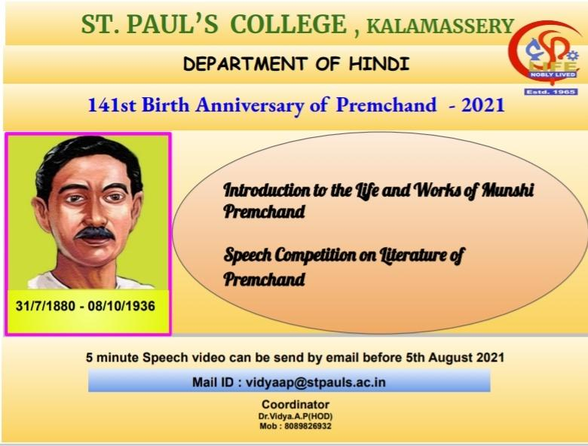

‘Speech Competition on Literature of Premchand’.

WINNERS

1)FIRST PRIZE
Harishankar.P.U
B.Sc Physics
2)SECOND PRIZE
Uthara Pradeepkumar
B.A Economics
3)THIRD PRIZE
Kavya Vijayan
B.Sc Physics
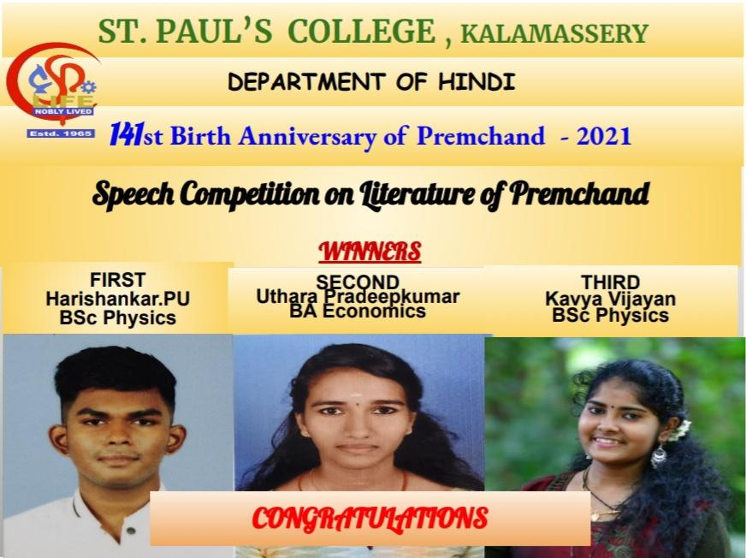

79th Death Anniversary of Rabindranath Tagore
7 August 2021

On the occasion of the 79th Death Anniversary of Legendary Nobel Prize laureate Rabindranath Tagore on August 7,the Department of Hindi remembers him by reading some of his best thoughts on Education.

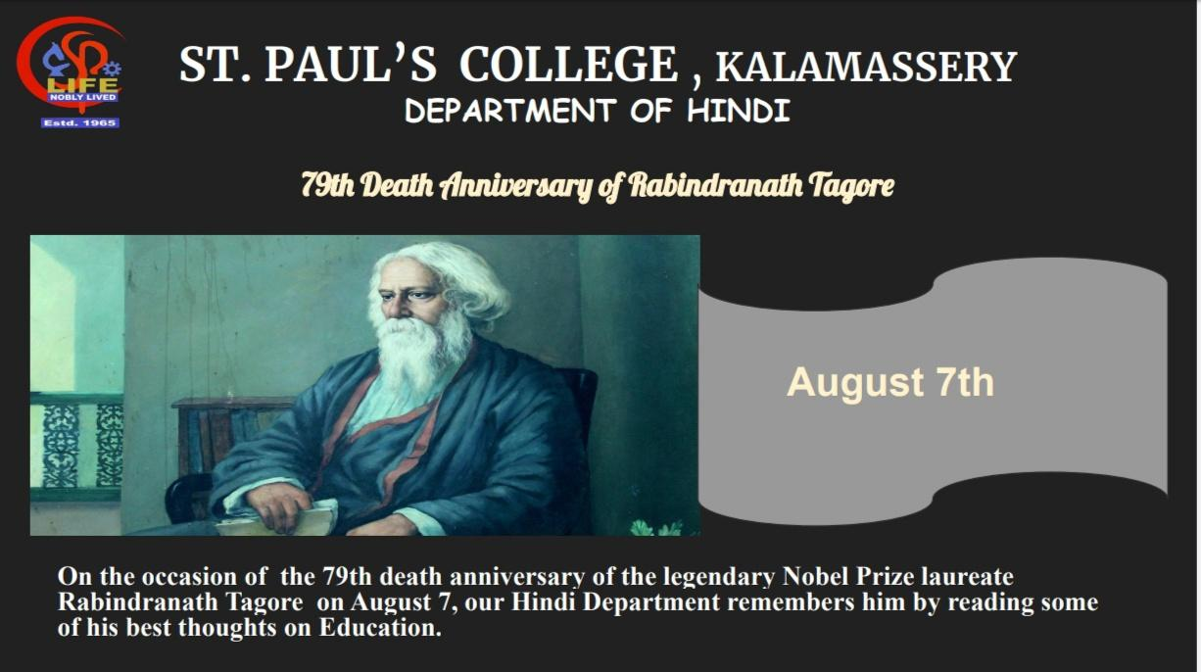

INDEPENDENCE DAY CELEBRATIONS

St Paul’s College Hindi, Malayalam & English Departments jointly organized the Independence Day celebrations in 2021.We conducted an Essay writing Competition on ‘Freedom in the Present times’.

Winners

1st Prize - Uthara Pradeepkumar
2nd B.A Economics

2nd Prize - Kavya Vijayan
2nd B.Sc Physics

ONAM CELEBRATION - 2021

The Department of Hindi celebrated Onam through Google Meet platform by various traditional programmes like Speech,Nadanpattu,Antakshari,Quiz,Sundarikku Pottu Kuthal on19th August 2021.

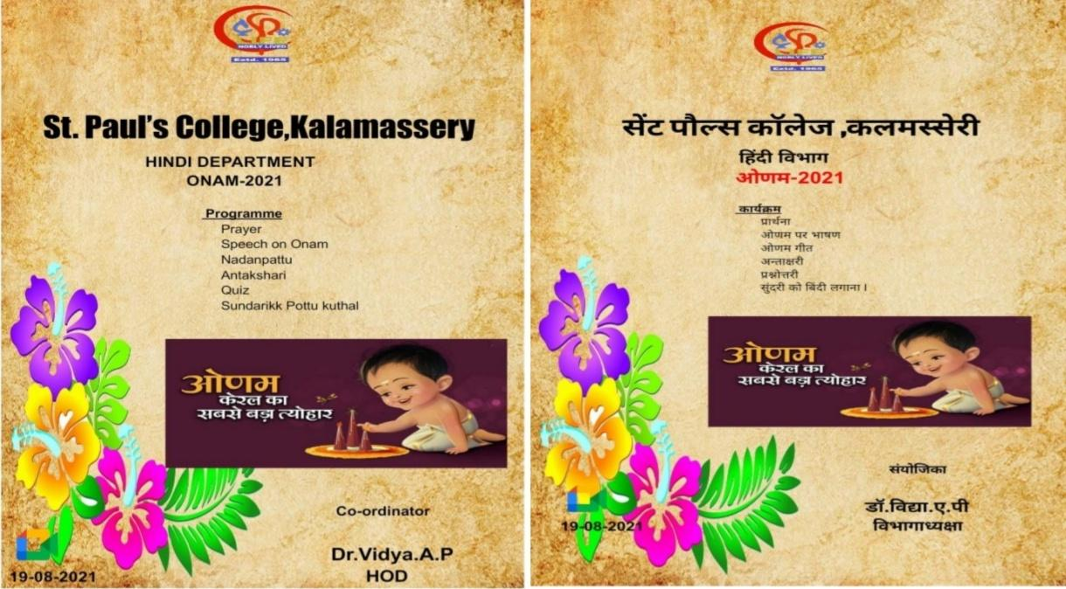

HINDI DAY CELEBRATIONS - 2021

As part of Hindi day Celebration, the Department of Hindi organized a Webinar on ‘SIGNIFICANCE OF HINDI’ on 14th September 2021. Due to the pandemic condition of Covid -19, it was conducted on an online platform. Dr. Shyamprasad.K.N, Associate Professor, Dakshin Bharat Hindi Prachar Sabha ,Ernakulam was the Chief guest and Speaker of the Webinar. Principal Dr. Savitha .S inaugurated this function . Mis.Lima from English Department gave Felicitation speech for the webinar and Welcome speech and vote of thanks is done by HOD Dr. Vidya. A.P

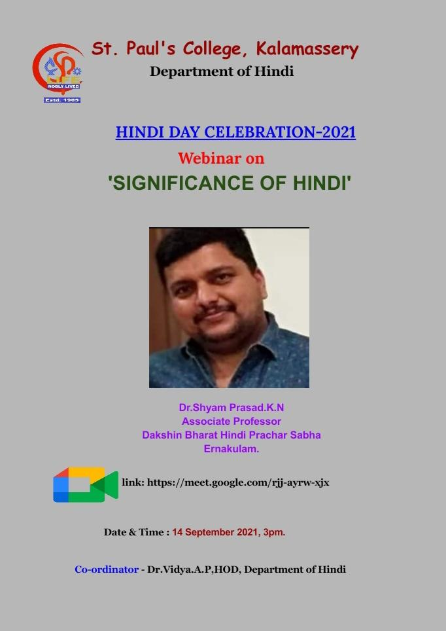

INVITED PROGRAMME

Department of Hindi St.Pauls College kalamassery organized a invited talk on 7th March 2022.Dr.Aneesh K .N. Assistant professor Department of Hindi, Cusat has delivered an Orientation Lecture onDrama:Konark as a part of invited talk.And he extended talk impossibilities and employability of higher education in Hindi.
Welcome speech is done by kavya P.U ,student co-ordinator.Vote of thanks done
by HOD Dr.Sinju.P.V.

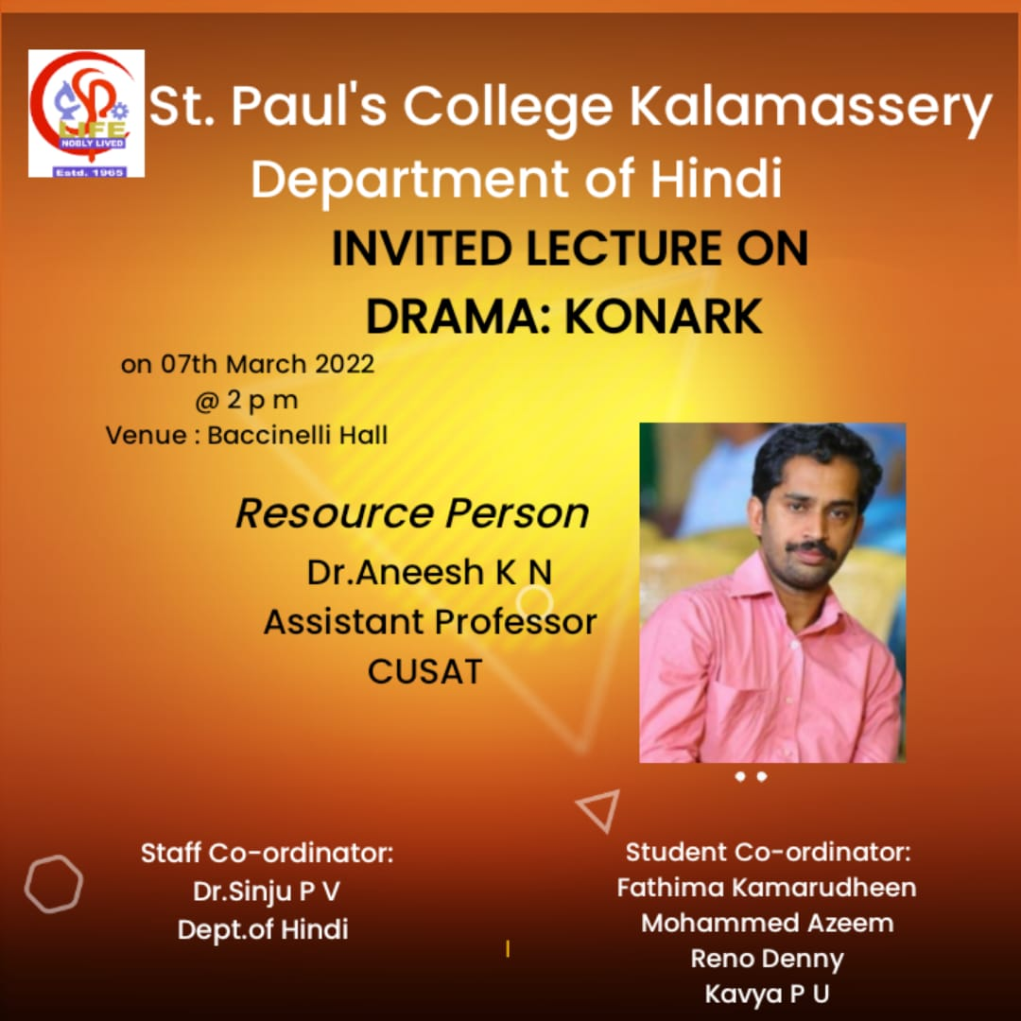

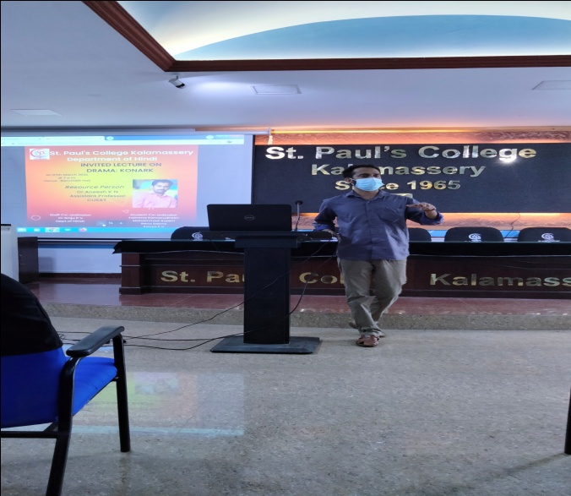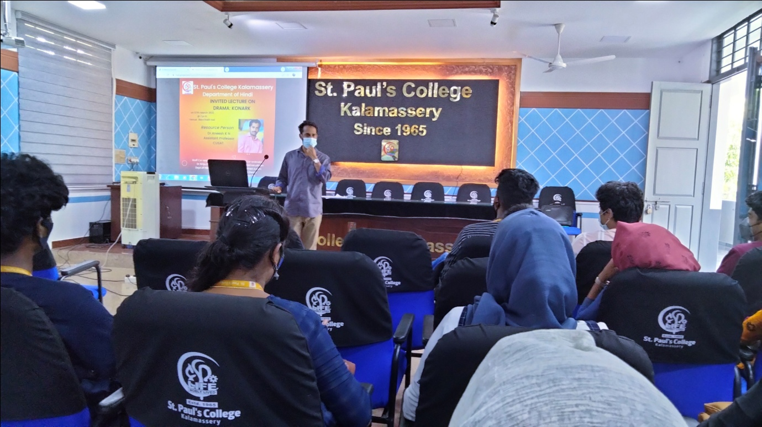

INTERNATIONAL MOTHER LANGUAGE DAY

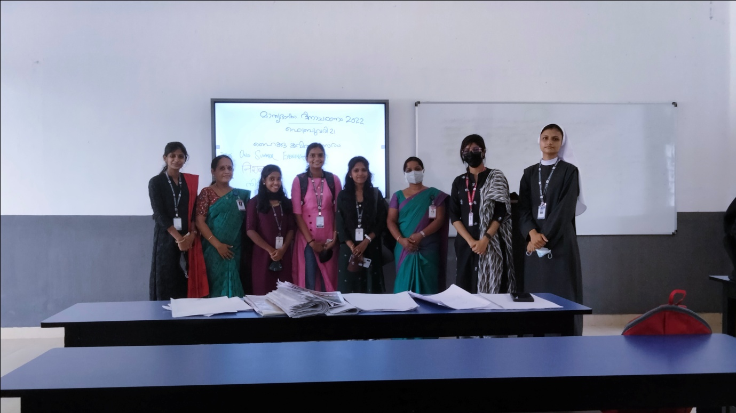

In collaboration with the Department OF Hindi, Malayalam and English St.Paul’s Collage ,Kalamassery organized
International Mother Language Day.The event was formally inaugurated by college principal Dr.Savitha K.S.The event started with oath taking ceremony.HoD of Hindi spoke on the importance of the mother language.conducted a hiku poem competition .vote of thanks done by HOD of Malayalam department.

Winners

Malayalam

1st : M meera (1st BA economics)
2nd : Parvathy Babu ( 2nd BCom)

Hindi

1st : Thara Elizabeth (1ST BCom CA)

2ND : ELIZABETH KISHKU ( 1st BA English )

English

1st :M .Mera (1st BA economics)
2nd :Rinz parveen (1st BA English)

