**National Seminar on MATERIALS FOR A SUSTAINABLE FUTURE,**

**First Author a,b, Second Authorb**

**a: Department of Chemistry, St.Paul’s College, Kalamassery, Kerala, India**

**b: Department of Chemistry, St.Paul’s College, Kalamassery, Kerala, India**

***chemistry@stpauls.ac.in***

**Abstract**

**(**A paragraph not exceeding 150 words, Times new roman, font size : 12, Line spacing :1.5, Format : Justified )

The National Seminar on "Materials for a Sustainable Future" holds paramount importance in the context of our rapidly evolving world. As we confront pressing global challenges like climate change, resource depletion, and environmental degradation, the need for sustainable materials becomes increasingly critical. This seminar serves as a platform for experts, researchers, and innovators to converge and exchange ideas on cutting-edge materials science and technologies that can pave the way for a more sustainable future. By fostering collaboration and knowledge-sharing, it empowers participants to explore novel materials, manufacturing processes, and applications that can reduce our ecological footprint, enhance energy efficiency, and promote circular economies. The outcomes of such seminars can catalyze groundbreaking developments in various sectors, including renewable energy, transportation, construction, and healthcare, contributing to a more environmentally conscious and economically viable world. In essence, this national seminar becomes a pivotal driver for innovation and progress towards a sustainable and harmonious future for generations to come.

**Keywords**: 3-5 words, Times new roman, font size : 12

1. **Introduction**

(Times new roman, font size : 12, Line spacing :1.5, Format : Justified )

St. Paul’s College, affiliated to Mahatma Gandhi University and Regulated by UGC is a prestigious arts and science college which functions under the Archdiocese of Verapoly. The college envisions to create a new enlightened generation which is socially committed, academically proficient, digitally updated and spiritually refined, so as to enable them to face the challenging needs of the changing times.The College started functioning from 13th July 1965 .At present the college offers postgraduate courses in Economics, Physics, Mathematics, Chemistry, Commerce and English

The Department of Chemistry, which came into existence in 1965. The chemistry Department became a fully fledged department with the beginning of a degree course in Chemistry in the year 1999. Post graduate course in Pure Chemistry started in 2003.

National Seminar on "Materials for Sustainable Future – MSF2023" The aim of this seminar is to bring together experts, researchers, academicians, and industry professionals to delve into the latest advancements, research, and innovations in the realm of materials science and sustainability.

.

1. **Materials and Methods**

**2.1 Materials**

(Times new roman, font size : 12, Line spacing :1.5, Format : Justified )

**2.2.** **Methods**

**2.2.1 Method 1**

(Times new roman, font size : 12, Line spacing :1.5, Format : Justified )

**2.2.2 Method 2**

(Times new roman, font size : 12, Line spacing :1.5, Format : Justified )

**2.3. Result**

**2.3.1 Table 1**

(Times new roman, font size : 12, Line spacing :1.5, Format : Justified )

|  |  |  |
| --- | --- | --- |
| **XXXXX** | **A** | **B** |
|  |  |  |

**Table 1. Table heading , times new roman, font 12, bold**

**2.3.2 Graph**

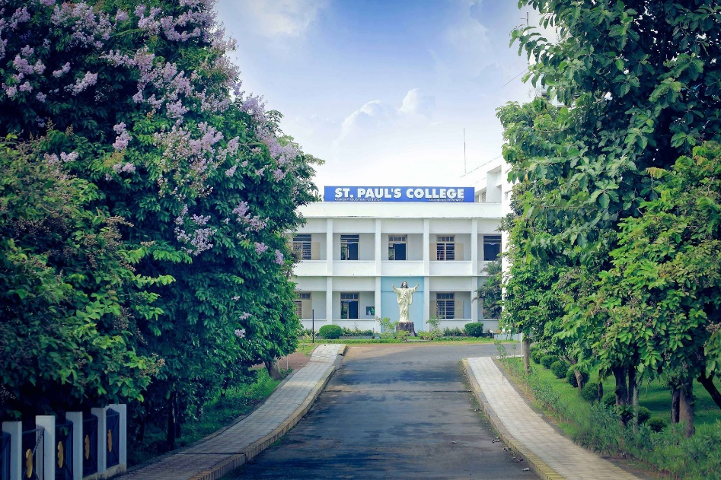

**Figure 1. Figure heading , times new roman, font 12, bold**

**Acknowledgement**

**Reference**